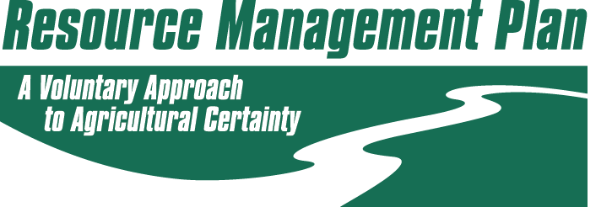

Prepared for:
Prepared by:
RMP Certification #:
NMP Certification #:
NMP Certificate Expiration Date:

I certify the following information has been prepared by me or under my direction and meets the requirements of the Virginia Resource Management Plan Regulations. I have reviewed all plan(s) included that were prepared by others and also certify those plan(s) were prepared by qualified individuals and meet the requirements of the Virginia Resource Management Plan Regulations.

RMP Planner Signature: _________________________________ Date: ________________

Description of the management unit, operation and concerns addressed in this plan:
(insert description narrative here)

Water and environmentally sensitive features:
(insert narrative about water and environmental concerns here)

