Virginia Soil and Water Conservation Board
Thursday, March 23, 2023
Hungry Mother State Park, Marion, Virginia

TIME AND PLACE
The meeting of the Virginia Soil and Water Conservation Board took place at 10:00 a.m. in the Lakeview Event Center at Hungry Mother State Park in Marion, Virginia.

VIRGINIA SOIL AND WATER CONSERVATION BOARD MEMBERS PRESENT

Charles A. Arnason, Chair
Adam D. Wilson, Vice Chair
Dr. Stephen R. Hill
Pamela Mason
Charles Newton
Matthew S. Wells, Director DCR, Ex Officio
Dr. Edwin M. Martinez, NRCS, Ex Officio

VIRGINIA SOIL AND WATER CONSERVATION BOARD MEMBERS NOT PRESENT

Jay C. Ford
Dr. Dahlia O’Brien
Two Vacancies

DCR STAFF PRESENT

Andrew Smith, Chief Deputy Director
Darryl Glover, Deputy Director, Soil and Water Conservation, Dam Safety and Floodplain Management
James Martin, Director, Division of Soil and Water Conservation
Christine Watlington Jones, Policy and District Services Manager
Michael Fletcher, Board and Constituent Services Liaison
Angela Ball, Conservation District Coordinator
Mandy Fletcher, Conservation District Coordinator
Stacey Horton, Conservation District Coordinator
Sara Bottenfeld, Agricultural Incentives Program Manager

OTHERS PRESENT

Dr. Daniel Goerlich, Virginia Cooperative Extension
John Womack, NRCS
Gary Boring, Virginia Association of Soil and Water Conservation Districts
Zach Jacobs, Virginia Farm Bureau

ESTABLISHMENT OF A QUORUM
With five (5) members of the Board present, a quorum was established.

CALL TO ORDER

Chairman Arnason called the meeting to order at 10:00 a.m. and asked for introductions.

WELCOME TO HUNGRY MOTHER STATE PARK

Kevin McDonald, Assistant Park Manager, welcomed attendees to Hungry Mother State Park. Hungry Mother was one of six original Virginia State Parks that opened in 1936. The park was built by the Civilian Conservation Corps. Many of those original buildings remain.

APPROVAL OF MINUTES FROM DECEMBER 7, 2022

Ms. Mason moved that the minutes from the December 7, 2022 meeting of the Virginia Soil and Water Conservation Board be approved as submitted. Mr. Wilson seconded and the motion carried.

DIRECTOR’S REPORT – Matthew S. Wells, DCR Director

Director Wells gave the Director’s report.

Director wells noted that budget negotiations continue in the General Assembly. He noted that there is a budget, but that the negotiations address amendments and additional funding. He noted the following legislative updates:

- HB1807 and SB1392 address floodplain development for state agencies.
  - The legislation addresses concerns raised by FEMA regarding the lack of enforceable standards for development activities occurring in floodplains by state agencies on state-owned land;
  - It ensures Virginia’s continued ability to participate in the National Flood Insurance Program;
  - The establishment of a single statewide standard will simplify and streamline the planning, design, and construction process for stage agencies.
  - State agencies will maintain the ability to choose to comply with local ordinances rather than the statewide standard.
- HB1485 and SB 1129 were “Bay backstop bills” that will help determine by a certain date if Virginia is on track to meet the BMP requirements. The date was moved to 2028 in recognition of the impact of COVID and the lack of funding.
- Other legislation requires the coordination of state agency actions regarding the use of native plant species and recognized the Clean Water Farm Award winners.

With regard to the budget, Director Wells noted that he had hoped to provide an update. He noted the following items were included in the Governor’s introduced budget.

- The introduced budget provided critical employees:
  - 4 federally funded positions transferred to general funds
    - Nutrient management planners (3) and data support services position (1)
  - 3 new dam safety engineer positions that will be federally funded
- The introduced budget also provided additional funding for the implementation of the VACS Program to offset the impacts of rising inflation.
  - $73.8 million to the Virginia Natural Resources Commitment Fund
    - $45.7 for areas within the Chesapeake Bay Watershed
    - $19.6 for areas outside of the Bay Watershed
    - $8.5 in additional technical assistance funding for Districts
  - $13.3 million for the WQIF Reserve
- An additional $50 million to the Virginia Natural Resources Commitment Fund
  - The Secretary of Natural and Historic Resources is charged with developing and submitting a plan for the allocation of the funds no later than September 1, 2023.
- $100,000,000 for the Resilient Virginia Revolving Loan Fund
  - $100,000,000 in the second year contingent on revenues

Director Wells again noted that these provisions were part of the Governor’s introduced budget. DCR continues to monitor budget negotiations.

AUDIT SUBCOMMITTEE

Mr. Wilson reported on the actions of the Audit Subcommittee.

The Performance Improvement Plan (PIP) for Evergreen SWCD has been approved. The District is implementing the actions included in the PIP.

The audits from 2022 were overall very good and a general letter outlining all of the common issues found by the auditors will be sent to all districts. A letter was issued to Skyline District outlining several actions that need to be taken by the District to address Issues found by the auditors. A letter was received from the Big Sandy District informing the Audit Subcommittee that actions have already been taken to address the concerns raised by the auditors. The Department has verified that the concerns have been addressed and a letter from the Audit Subcommittee will be sent to that District in recognition of the District’s actions.

DAM SAFETY AND FLOODPLAIN MANAGEMENT

Division Report – Darryl Glover, Deputy Director for Soil and Water Conservation and Dam Safety and Floodplain Management

Mr. Glover gave the Division report on behalf of Wendy Howard Cooper. A copy of the report is included as Attachment #1.

SOIL AND WATER CONSERVATION

Division Report – James Martin, Director, Division of Soil and Water Conservation

Mr. Martin gave the report for the Division of Soil and Water Conservation. A copy of the report is included as Attachment #2.

APPROVAL OF BUDGETS FOR WATERSHED IMPROVEMENT DISTRICTS – Christine Watlington Jones, Policy and District Services Manager

Lake Barcroft

Ms. Watlington Jones presented the budget proposal from the Lake Barcroft Watershed Improvement District. She reviewed the following items.

- Beginning of FY2024; balance of $1,451,981 in 4 reserve accounts
  - Expect to collect property taxes of $1,382,000 (a 3.5% increase)
  - Other modest income sources will provide $2,845,981
- Expenditures of $1,548,200:
  - $945,700 for operating expenditures (personnel, administration, overhead, maintenance, equipment)
  - $425,000 for dam renovation projects
  - $135,000 for dredging and silt removal
  - $42,500 for general capital expenditures
  - Expected balance of $1,297,781
- WID will focus on six-year recertification plan; evaluate impact of stormwater runoff on lake and dam; and continue to locate a permanent for dredge spoil disposal

BOARD ACTION

Mr. Newton moved that the Virginia Soil and Water Conservation Board approve the Lake Barcroft Watershed Improvement District FY2024 budget as submitted by the Northern Virginia Soil and Water Conservation District and presented by the Department.

Ms. Mason seconded and the motion carried.

Timberlake

Ms. Watlington Jones presented the budget proposal from the Timberlake Watershed Improvement District. She reviewed the following items.

- Interest rate on loan has been reduced from 4.5% to 4.25%
- Principal balance is now $494,723
- Annual loan payments are $53,192; monthly payments are $4,432.63
- WID has received $37,828 from first billing cycle in Campbell County
  - Anticipated real estate tax revenue was projected at $63,612 for calendar year 2022
- Tax rate remains constant at $0.15 per $100 value on total property assessments.
- Anticipated expenses:
  - Operating expenses $4,500
  - Interest expenses $19,442
  - Loan Amortization $33,750
  - Total $57,692

BOARD ACTION

Mr. Wilson moved that the Virginia Soil and Water Conservation Board approve the Timberlake Watershed Improvement District FY2024 budget as submitted by the Robert E. Lee Soil and Water Conservation District and presented by the Department.

APPROVAL OF TRUSTEE FOR LAKE BARCROFT WATERSHED IMPROVEMENT DISTRICT – Christine Watlington Jones, Policy and District Services Manager

Ms. Watlington Jones presented the request for approval of the appointment of a Trustee to the Lake Barcroft Watershed Improvement District. She noted:

- At Northern Virginia Soil and Water Conservation District’s meeting on February 28, 2023, the District accepted the resignation of Gerald (Jerry) Mendenhall as a Lake Barcroft Watershed Improvement District (LBWID) Trustee
- Board voted to recommended Brenda Pierce as a Trustee
- The term is for five years

Ms. Mason moved that the Virginia Soil and Water Conservation Board approve the appointment of Ms. Brenda Pierce as Trustee for the Lake Barcroft Watershed Improvement District to replace Mr. Gerald (Jerry) Mendenhall. This approval reflects actions taken by the Northern Virginia Soil and Water Conservation District.

Dr. Hill seconded and the motion carried.

AGRICULTURAL BMP COST-SHARE MANUAL AMENDMENTS – Christine Watlington Jones, Policy and District Services Manager

Agricultural BMP Cost-Share Manual Amendments

Ms. Watlington Jones reviewed the recommended changes to the BMP specifications.

She noted that Department recommendations included the following:

  - After discussions with Districts that participated in the Whole Farm Approach Pilot Program this year, the following revisions are being recommended:
    - Clarification that the practices (WFA-CC and WFA-NM) are not eligible for tax credits. There was language copied from individual specifications that referenced tax credits; however, it is stated in the “General Policies and Specifications” section under “Rates” that the practices are ineligible or tax credits.
    - Language has been added to both the WFA-CC and the WFA-NM related to unimproved pastures being eligible to participate in the WFA. Unimproved pasture acres (pasture acres that do not receive nutrient management or nutrient applications) may be excluded from the tract within the nutrient management plan.
    - Payment for PSNT sample collection has been included in the WFA-NM specification.

- The Department recommends that the Dry Manure Storage Structure Agreement be removed from the WP-4 specification and instead be included in the Glossary as an additional form. The requirement to sign the Dry Manure Storage Structure Agreement, or similar District agreement, remains and is included in several other specifications (WP-4B; WP-4LC; WP-4LL; WP-4SF), although the Agreement is not currently included with all specifications. References to the Agreement in several of the specifications were outdated; maintaining one version of the Agreement ensures consistency within the Program.

Dr. Hill advised that he had been requested by the Culpeper SWCD to address the issue of piggyback funding. Culpeper would like to see the following amendment to the existing language in the BMP Manual: “Districts and other governmental agencies may choose to combine resources to fund mutually high priority practices up to a maximum of 100 percent of eligible costs.”
Ms. Watlington Jones advised that in 2022 there were changes to the manual that authorized non-profits and other organizations to contribute funding to producers to ensure procedures had 100% of their eligible costs paid, even if VACS only paid 75%. The Culpeper District is requesting the same authorization for other state and federal funding.

Ms. Watlington Jones advised that the initial language has been in place since at least 2014. She noted that Districts can pay up to the VACS rate and other private entities or non-profits may pay the remaining 25%.

Recommended revisions to the VACS BMP Manual for FY2024 Guidelines – Christine Watlington Jones

Ms. Watlington Jones reviewed the remaining Department recommendations for other sections of the manual.

    - Guidelines
- Language has been added that clarifies that Districts are expected to only work within their own service areas. In certain situations, Districts are allowed to accept applications from producers outside of their service areas, but only with approval of the other impacted District.
- As the Whole Farm Approach specifications are included in the VACS Manual, this language has been stricken.
- Language has been added to clarify that practices may be eligible to participate in carbon credit programs or other similar programs. However, the credits generated cannot be used to satisfy the requirements of any local ordinance, mitigation bank, nutrient trading program, or state or federal law, regulation, or permit.
- Language has been added that clarifies that resource reviews are only needed when new components are needed and where ground disturbing work is occurring to maintain an existing component.
- Language has been added which clarifies that either a member of DCR’s Agricultural BMP Engineering Services Program or an individual with appropriate levels of EJAA must review the project to ensure it meets all VACS Program qualifications and practice specifications prior to District Board approval of the project. This is current procedure for piggyback funded projects.
- Language has been added to reflect the recommendation of the AgBMP Technical Advisory Committee related to a bundle variance.
- Language has been stricken referencing DCR form 199-071. This is the VACS Contract Part I, II, and III.

    - Tax Credit
- Language has been added to clarify the percentage of tax credit that a producer with an approved Resource Management Plan is eligible to claim if the producer participates receives cost-share funding.
- SWCD has been replaced with “District” for consistency.
- Reference to a specific year has been stricken; instead reference has been made to “each year”.
- Language has been added related to soil conservation plans to provide reference to the types of plans that are considered soil conservation plans and other requirements established for those plans.
- Numbering was corrected.

    - Poultry Litter
- Removed language requiring certain documentation to be submitted no later than July 31, 2023. The applicant’s nutrient management plan is recommended to be required with the application (Page VII-3). Other documentation, such as the Field Application Record, the Chain of Custody Form, and the certified scale weight tickets, are required to be submitted as part of the request for payment submission. This is an existing requirement and is not needed by a certain date; rather it is needed when a producer is requesting payment.

- Based on the latest information from CAST (Manure Transported versus Land Available Data), counties are recommended to be added as eligible counties or removed as eligible counties for FY2024.

- Additional minor amendments, including formatting corrections, have been made to the documents as well.

    - Small Herd Initiative
- The Department is recommending a $15,000 increase in the Initiative cap. This will increase the possible funding amount available to a producer to $50,000.
- Language has been removed that is no longer necessary, as the Initiative is available statewide.
- Dates have been changed to reference FY2024 rather than FY2023.
- Other minor formatting edits have been made.

    - Glossary
- Added language clarifying that the definitions included in the Glossary are solely for use with the Virginia Agricultural Cost-share Program. Additional language recognizes that other organizations and programs may use similar terms but the terms can mean different things. Similar language that was previously included in the definition of “live water” has been stricken.

- Definition of “animal equivalents” has been revised to “animal units”, which is more commonly used by the Program now. The definition remains the same.
- “Highly managed hayland” has been revised to reflect the recommendation made by the AgBMP Technical Advisory Committee.
- “Karst” has been defined as recommended by the AgBMP Technical Advisory Committee.
- “State piggyback” has been renamed “piggyback funding” and has been minimized.
- “Spot check” has been removed and replaced with “verification”. This reflects current Program terminology.
- The WP-4 Risk Assessment is included as a new form. This is a recommendation of the AgBMP Technical Advisory Committee.
- The Dry Manure Storage Structure Agreement is included in this section of the Manual. This is a recommendation of the Department.

    - Other documents

- Cover of Manual:
  - Dates have been updated to 2024
  - Form number has been removed

- Schedule:
  - Dates have been updated to 2023 and 2024

- Table of BMPs:
  - Revision dates have been updated
  - Names and specifications have been updated to reflect recommendations of the TAC and the Department

- Contract Part I:
  - Language has been added to clarify that cost-sharing funding or tax credits are not to be used in a mitigation bank, nutrient trading program or to comply with any state or federal law, regulation, or permit

- Administrative Review Checklist:
  - Revisions have been made to clarify what is being reviewed;
  - Relocation of items on the checklist to more carefully link the questions to the document being reviewed; and
  - To document which technical staff person is responsible for the file being reviewed.

Mr. Glover noted that the Department is recommending an increase of the initial payment by $15,000 to a total of $50,000. Based on a review of livestock exclusion practices installed since 2020, the installation costs have increased; the recommended increase reflects the more accurate costs to install these practices.

Mr. Wilson expressed a concern regarding the poultry litter transport program. The Department included Washington County as an “eligible” county for litter to be transported into based on the scientific data available. He raised concerns regarding the risk of spreading the avian flu with any transportation of animal waste; spreading this disease could close entire operations. He recommended that producers in Washington County seeking to use poultry litter should contact in County providers. Mr. Wilson committed to discussing this recommendation with the facility in Washington County as well as producers within the county.

APPROVAL OF DISTRICT DIRECTOR RESIGNATIONS AND APPOINTMENTS – Christine Watlington Jones, Policy and District Services Manager

Ms. Watlington Jones presented the list of recommended resignations and appointments.

Big Sandy

Resignation of Mr. Tim Looney, of Buchanan County, effective 12/21/2022, elected director (term of office expires 12/31/2023).

Appointment of Mr. Jerry Ward, of Buchanan County, effective 3/23/23, to fill the unexpired elected director position of Mr. Tim Looney (term of office expires 12/31/23).

Colonial

Appointment of Mr. Tim Beale, of York County, effective 3/23/2023, to fill the vacant at large appointed director position (term of office expires 12/31/2026)

Peanut

Appointment of Mr. Daniel Judkins, of Surry County, effective 3/23/2023, to fill the unexpired elected director position of Mr. Keith Seward (term of office expires 12/31/2023).

Shenandoah Valley

Resignation of Mr. William Latham, of the City of Harrisonburg, effective 2/15/2023, elected director (term of office expires 12/31/2023).

Appointment of Ms. Kristen Ulmer, of Rockingham County, effective 3/23/2023, to fill the un-expired elected director position of Mr. Stephen Lohr (term of office expires 12/31/2023).

Southside

Resignation of Mr. Eugene Wells, Jr., of Charlotte County, effective 1/11/2023, elected director (term of office expires 12/31/2023).

Appointment of Mr. William Nichols, of Charlotte County, effective 3/23/2023, to fill the un-expired elected director position of Mr. Eugene Wells (term of office expires 12/31/2023).

Three Rivers

Appointment of Ms. Sara Henley, of King and Queen County, effective 3/23/2023, to fill the un-expired elected director position of Mr. Robert Bland (term of office expires 12/31/2023)

BOARD ACTION

Mr. Newton moved that the Virginia Soil and Water Conservation Board approve the appointments of individuals being recommended. Mr. Wilson seconded and the motion carried.

APPROVAL OF PAYMENTS FOR INSTALLATION OF CERTAIN REMOTE MONITORING SENSORS BY THE DEPARTMENT – Christine Watlington Jones

Ms. Watlington Jones advised that, under previous Board approved motions, the Department procures all remote monitoring equipment for District owned dams. Individual Districts are reimbursed for the costs associated with installing the equipment.

She further noted:

- This process has been effective and efficient for the equipment that utilizes cellular communications.
- There are approximately 21 dams that will not be able to utilize cellular based equipment for the remote monitoring equipment.
- Equipment for these dams will need to rely on satellite-based communications.
- In order to ensure the equipment works correctly, a specialized installation contractor is required.
- The contractor must be familiar with the satellite receiver and must be able to adjust the receiver in the field in order to receive the best possible signal.
- The Department is requesting authorization from the Board to procure the necessary equipment and to be able to pay for the installation of the equipment.
- There will be cost savings and efficiencies if the Department is responsible for coordinating the installation of this equipment.

BOARD ACTION

Mr. Newton moved that the Virginia Soil and Water Conservation Board authorize the Department to procure remote monitoring equipment for all Soil and Water Conservation District-owned dams. Additionally, the Department is authorized to pay for the installation of equipment that relies on satellites for communication. The funding for the installation of this type of equipment shall be provided from the Soil and Water Conservation District Dam Maintenance, Repair, and Rehabilitation Fund.

Mr. Wilson seconded, and the motion carried.

PARTNER REPORTS

Natural Resources Conservation Service

Dr. Martinez gave the report for the Natural Resources Conservation Service. A copy of the report is included as Attachment #3.

Dr. Martinez introduced John Womack the Assistant State Conservationist for Partnerships and Initiatives.

Virginia Cooperative Extension

Dr. Goerlich gave the report for Virginia Cooperative Extension. A copy is included as Attachment #4.

Virginia Association of Soil and Water Conservation Districts

Mr. Boring advised that he did not have a prepared report. He noted that the Area IV Spring Area meeting had been held on Tuesday.

OLD BUSINESS

There was no old business.

NEW BUSINESS

Chairman Arnason advised that several letters had been received from Districts regarding the need for assistance with human resources. He noted that information is still being gathered. He responded to each District and provided copies to the Board. The Board and staff, working with the Virginia Association of Soil and Water Conservation Districts, will work over the next several months to complete a more thorough assessment of the human resource related needs.

There was no additional new business.

PUBLIC COMMENT

Ms. Mason advised that the EPA Chesapeake Bay Program recently made available grant funding for the planting of urban trees, riparian buffers, and wetlands. The funding must be provided to a subdivision of the Commonwealth. Colonial SWCD has offered to partner with localities that are not part of a District.

UPCOMING MEETINGS

- April 27, 2023; Pocahontas State Park, Chesterfield
- May 25, 2023; Department of Forestry, Charlottesville

ADJOURN

There was no further business and the meeting adjourned at 12:00 p.m.

Attachment #1

Division of Dam Safety and Floodplain Management
Division Director’s Report
March 23, 2023

Prepared by Wendy Howard Cooper
Division of Dam Safety and Floodplain Management

Mr. Chairman, members of the Virginia Soil and Water Conservation Board, please accept this Dam Safety and Floodplain Management Division Report.

The Dam Safety, Flood Prevention and Protection Assistance Fund (Fund) grant period closed on February 28, 2023. DCR received 120 applications requesting more than $3.3M from the Fund. Up to $5M was made available to dam owners to help bring dams into compliance. Grant reviews are underway and recommendations will be provided to the SWCB at the May 2023 meeting.

At the December meeting of the SWCB, DCR reported there were 1828 dams of regulatory size with an Undetermined Hazard Classification. That number has been reduced from 1828 to 1719. This is a reduction of 109 dams. The number of High Hazard dams have increased from 371 to 381 or an increase of ten dams. The Dam Safety team continues to work diligently with dam owners to brings dams into compliance.

April is Low Head Dam Awareness Month

May 31st is Dam Safety Awareness Day

A more comprehensive report will be provided at the May meeting.

Attachment #2

Division of Soil and Water Conservation Division Director’s Report
Spring 2023 Prepared by James E. Martin;
Director, Division of Soil and Water Conservation, DCR

Members of the Virginia Soil and Water Conservation Board, please accept this Soil and Water Conservation Division Report.

SWCD Staff Training
The Department has continued to collaborate with the Association to lay out a robust curriculum of training classes for SWCD staff and Conservation Planners in training. Additionally, we have met with the SWCD Employees Association and have begun work to collectively develop an expanded curriculum of SWCD employee training needs. This effort recognizes that there are some training responsibilities that reside at the employing SWCD, some that may be fulfilled by the Employee Association, and others that DCR will be responsible for. Some trainings may require District employees to travel to a centralized (or regionalized) location for several days. Districts should plan for these training related travel costs and employee time away as they develop their annual budgets and plans of work. We will work with the Association to provide as much advance notice of these training opportunities as possible. A curriculum of currently planned and available courses is attached to this report.

Rebuild on the Conservation Application Suite
During the 2022 General Assembly Session, the Department received $1.5 million to undertake a rebuild of the Conservation Application Suite. As part of this rebuild, the Department contacted many Districts for assistance on what should change in the new applications and what should remain similar. The Department has begun working with the Virginia Information Technology Agency (VITA) to start the process necessary to request bids. This will be a multi-year project and we would like to thank all of those who have helped the Department with this effort so far.

Resource Management Plan (RMP) Program Reviews
Division RMP Staff will be initiating annual RMP Program Reviews at six Soil and Water Conservation Districts. Those Districts are Chowan Basin, Lake Country, Natural Bridge, Peanut, Robert E. Lee, and Southside. These Program reviews are required by RMP regulations. Districts scheduled for review were notified by email in February.

Proposed Expansion of Whole Farm Approach (WFA) Pilot
The Division will recommend to the Soil and Water Conservation Board that the WFA practices be implemented in more Districts throughout the state; this includes Chesapeake Bay Districts and Southern Rivers Districts. The pilot has been very popular, garnering more than $13 Million in requests in the seven Districts that are currently participating.

2023 AgBMP Technical Advisory Committee
The 2023 AgBMP Technical Advisory Committee (TAC) will begin its work in July, as usual. Later this spring, requests for suggestions from Districts, partners, and stakeholders will be sent from Sara Bottenfield, our Agricultural Incentives Program Manager. She will also be requesting any changes in the participants for each organization at that time. Suggestions and changes in who participates on the TAC will be due back to the Department in late May.

Transferring funds between Districts and back to the Department
Districts have been encouraged to consider transferring cost-share funds, and the associated technical assistance funds, as soon as possible, to other Districts that are in need of additional funds. Districts are able to transfer funds back to the Department as well; those decisions should be made as early as possible as well.

Virginia State University (VSU) Small Farms Outreach Program (SFOP)
VSU-SFOP hosts numerous workshops each month providing education, resources, and technical assistance to small and beginning farmers. Several Districts have successfully partnered with VSU on workshops and other outreach events. Districts have been encouraged to explore the VSU-SFOP website (https://www.ext.vsu.edu/small-farm-outreach-program), sign up for their e- newsletter (copy attached to this report) and continue to seek opportunities to partner with them to reach this important community of underserved farmers. VSU Small Farm Specialists attended a number of Area Spring Meetings to continue to build relationships between Districts and VSU-SFOP.

2

Date | Training | Location
2/22/2023 | VASWCD: Marketing Committee (DCR's Rebecca Jones as speaker) | Virtual
2/23/2023 | VACS BMP & Cost Share Training | Virtual
2/28/2023 | VASWCD: Legislative Training | Virtual
3/2/2023 | VASWCD: Admin/Ops Committee (Planning Mtg) | Virtual
3/15/2023 | VASWCD: Education Training Topic ‐ Adapting to Climate Change | Virtual
4/12/2023 | VASWCD: HR Trends for 2023 | Virtual
4/25/2023  4/26/2023 | Conservation Selling Skills | Lynchburg
5/9/2023 | VASWCD: Admin/Director In Person Training: Att. D: Budget  Template Training | Richmond
5/16/2023 | Perennial Stream ID | James City County
6/7/2023 | VASWCD: Admin/Ops Mtg: Att D. Training Follow UP | Virtual
6/8/2023 | VASWCD: Education Committee | In‐person
June | VACS Updates | Virtual
8/22/2023  8/23/2023  8/24/2023 | VACDE: Graves Mountain Summer Training | Syria
Tentatively in August, September,  or October | RUSLE2 Training | In‐person
10/5/2023 | VASWCD: Education Committee | Virtual
10/17/2023  10/18/2023 | Virginia Resource Concerns | Virtual
Tentatively in October ‐  November | DCR Conservation Planner Program | In‐person
12/4/2023  12/5/2023 | VASWCD: Annual Meeting | In person

Additional Conservation Planning Program courses
On demand | Overview of Water Quality Resource Assessment | COVLC
On demand | Nitrogen Management and Concerns | COVLC
On demand | Phosphorus Management and Concerns | COVLC
On demand | Sediment Management | COVLC
On demand | Water Bodies | COVLC
On demand | Pest Management and Water Quality Implications | COVLC
On demand | Water Management | COVLC
On demand | Virginia Water Concerns | COVLC
On demand | Pesticide Management Orientation | VT Online

NOTE: COVLC is the Commonwealth of Virginia Learning Center

Additional Trainings Under Development (tentatively later this fall)
Division of Risk Management Training | Virtual
VCAP Certificate Training Program (Cohort II) | In‐person and virtual components
Additional resources are available at: VASWCD Training Resource Library ‐ https://vaswcd.org/virtualtraining/
Training opportunities February 28, 2023



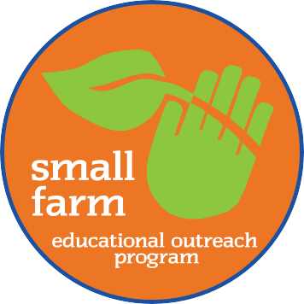
SFOP Quarterly
NEWSLETTER
WINTER 2023

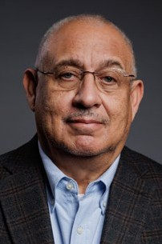
Dear Small-Scale Farmers, Ranchers and Veterans,

Happy New Year! We hope 2023 is off to a great start and will be a prosperous year for you and your agricultural endeavors.
Remember the Small Farm Outreach Program can help you thrive by providing agricultural education, training, outreach services and technical assistance to meet your needs.
In this issue, you’ll discover seasonal ag tips, learn about free workshops and get a glimpse into an exciting new online certification program launching this spring.

The new program enables those who successfully complete the course to apply for an FSA loan since VSU is licensed to conduct this FSA prerequisite training.

We’d like to encourage you to stay safe by implementing farm-safety protocols and following the Centers for Disease Control (CDC) guidelines.

For more information, view the SFOP calendar of events at https://www.ext.vsu.edu/small-farm-outreach- program or visit the Small Farm Resource Center at https://www.ext.vsu.edu/small-farm-resource-center.

Keeping you informed, William Crutchfield, SFOP Director


Petersburg League of Urban Growers Helps the Community Flourish
Tyrone Cherry

By Tyrone Cherry

With a focus on the community and black, indigenous, and people of color (BIPOC) farmers and youths, the

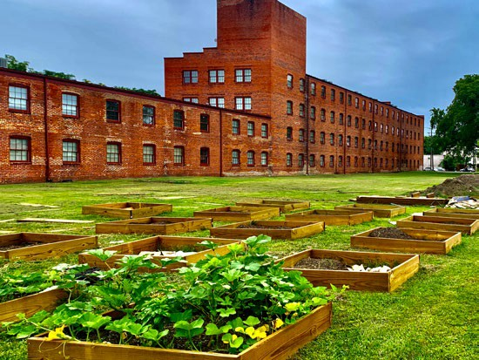
Petersburg League of Urban Growers, a not-for-profit organization, fosters food security, helps farmers grow thriving enterprises, and prepares youths for the future by planting seeds of knowledge and providing
access to land.

“ P.L.U.G. empowers the people of Petersburg, Virginia, to practice healthy lifestyles, self-sufficiency, and sustainability through gardening, education, and skills
training,” said Tyrone Power Cherry III, social entrepreneur and advocate for education.
The organization manages a quarter-acre community garden and co-manages smaller community gardens with local neighbors to make nutritious seasonal foods available. Also, in partnership with Agrarian Trust, P.L.U.G.

—continued on page 2

2 SFOP Quarterly Newsletter · Winter 2023

Petersburg League of Urban Growers continued from page 1
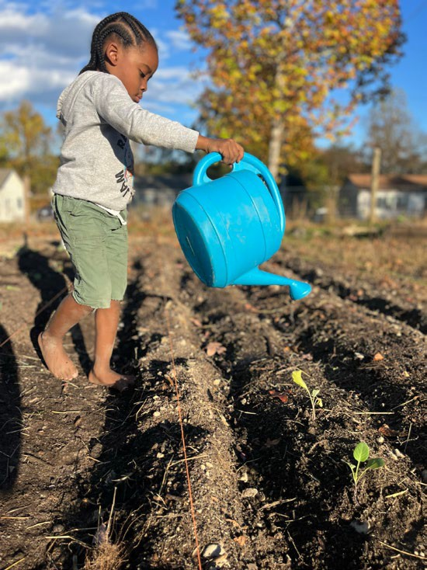
recently developed the Petersburg Oasis commUNITY Farm. These five acres serve as an incubator farm to help BIPOC farmers develop their farm enterprises and navigate the urban-agriculture industry.
P.L.U.G. designed and developed the Petersburg Oasis Youth Farm, a small outdoor learning space for local youths to learn and implement regenerative farming techniques.
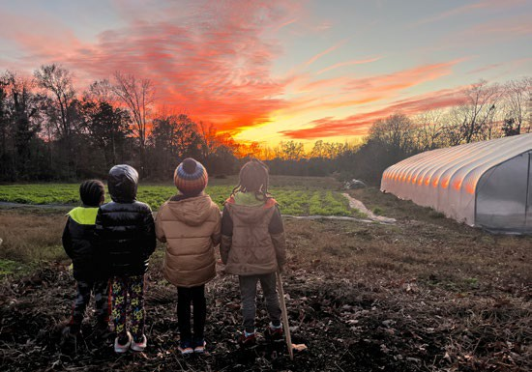
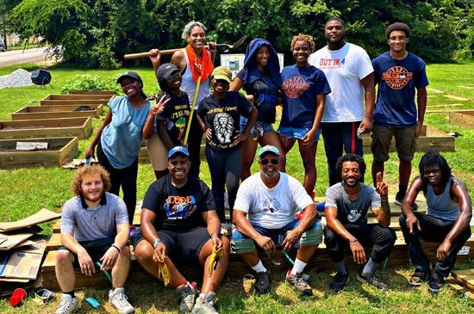

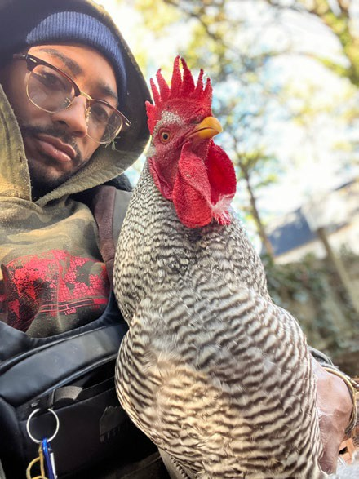
Furthermore, P.L.U.G. offers the Learn, Grow, Eat, & GO! program to students 4-18 years old via Virginia State University College of Agriculture and Virginia Cooperative Extension. This interdisciplinary program uses a research- and evidence-based curriculum developed by the International Junior Master Gardener® Program, and combines academic achievement, gardening, nutrient-
dense food experiences, physical activity, and school and family engagement. Upon completing the 10-week Junior Master Gardener® Program (2 lessons/week), students become certified Jr. Master Gardeners.
—continued on page 3

SFOP Quarterly Newsletter · Winter 2023 3

Miles J. Jones Elementary School Partners with Small Farm Outreach Program to Help Children Develop Science Skills

By Sonya Shaw, principal at Miles J. Jones Elementary School

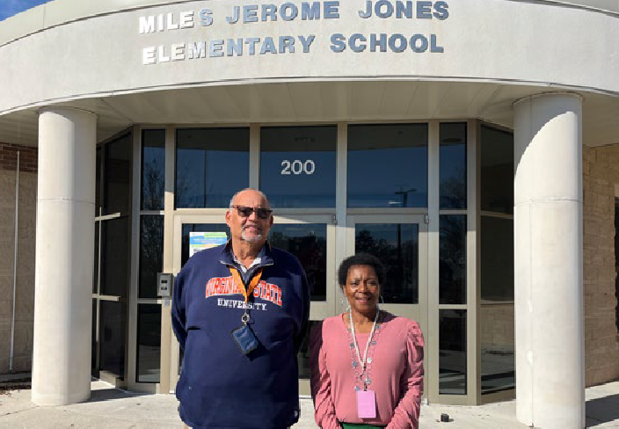
Miles J. Jones Elementary School is thrilled about its upcoming partnership with Virginia State University College of Agriculture and the Small Farm Outreach Program.
James Gibson, SFOP regional program assistant, and Sonya Shaw, Miles J. Jones Elementary School principal.
Miles Jones is an urban-based, Title I elementary school in the city of Richmond, Virginia, that serves over 550 students, the majority of whom are currently living below the national poverty line.
After touring the expansive agricultural facilities at VSU’s Randolph Farm, two of my associates and I met with William Crutchfield, director of SFOP, and James Gibson, SFOP program assistant for Central Virginia to design a way to introduce small farming to our students.
“SFOP is always happy to partner with organizations, especially schools, to help advance young people’s understanding of agriculture,” said Crutchfield.

Many of the students have very limited, if any, experience with farming and Virginia’s natural resources. We are concerned that despite rigorously teaching the Virginia Science Standards of Learning each year, students cannot seem to apply the concepts to the real world.
This partnership will help alleviate those concerns by connecting the SOL concepts with VSU projects and research. This real-world experience will support our learners in a fresh, new way.
It is our hope that forming a partnership with the Small Farm Outreach Program will not only help our students academically but also will inspire them as they make

future decisions regarding higher education and their career paths.
“This partnership is indicative of Greater Happens Here at VSU,” said Dr. Robert N. Corley III, interim dean and 1890 administrator for the College of Agriculture and vice provost for Academic and Student Affairs. “Greater Grows Here at the College of Agriculture where stellar academics till the soil of fertile minds, state-of-the-art research helps develop evidence-based best practices and outreach programs positively impact Virginia’s students, youths, small farms, local communities
and economy.”

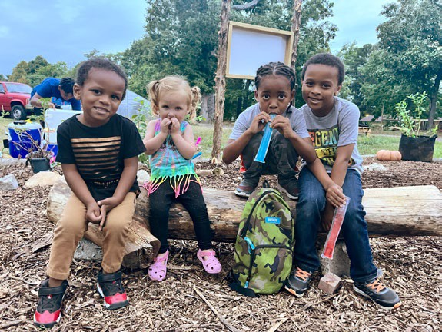
Petersburg League of Urban Growers
continued from page 2

To introduce the benefits of urban agriculture to the local community, throughout 2023, P.L.U.G. is hosting an educational experience, “How to Survive in the Food Desert,” monthly at the Petersburg Oasis Youth Farm 535 Beech Street, Petersburg. “We are using a pay- what-you-can campaign,” said Cherry. “Participants make an impact investment that they can afford and proceeds go towards our commUNITY action projects.”
For more information about P.L.U.G., email growwiththeplug@gmail.com.

4 SFOP Quarterly Newsletter · Winter 2023

Small Farm Outreach Program’s 2022 Annual Conference Celebrates and Educates
More than 200 people gathered at the 2022 Small Farm Outreach Program’s annual conference, “Farming
in Challenging Times,” at the Renaissance Hotel in Portsmouth. Attendees were empowered by expert speakers and panelists, gathered information from vendor exhibitors and gleaned insights from other farmers during bus tours. Panelists discussed financial fitness, crop insurance, marketing, farm safety, mental health, soil health, and disaster preparedness.
Four buses went to Slade Farm in Surry, Dayspring Farm in Cologne, and Bees Knees Farm in West Point. The ride offered an opportunity to network. The tours provided insights into the operation of these award-winning farms and an opportunity to ask questions.

The conference culminated with the announcement of the 2022 SFOP award winners Luke Hallman, Farmer of the Year; Clifton Slade, Volunteer of the Year; Grace
Summers, Program Assistant of the Year; Alston Hilliard,
Star Award; and USDA NRCS 2022 Minority Farmer of the Year, Thelonius Cook. In a surprise twist, the SFOP Advisory Board presented William Crutchfield, director of SFOP, with its Outstanding Leadership Award.

With an unwavering commitment to restoring and maintaining the soil naturally, Dennis and Sarah Williams of Bees Knees Farm & Creamery ensure their chickens, goats,
pigs, rabbits and turkeys are rotated regularly to graze on fresh pasture and woodland. This process benefits the animals, the land and consumers.

First row, left to right: Dr. Robert N. Corley III, interim dean/1890 Extension administrator of Virginia State University College of Agriculture and vice provost for Academic and Student Affairs, joins the 2022 SFOP and USDA NRCS award winners on stage, including Thelonius Cook, USDA NRCS Minority Farmer of the Year; Luke Hallman, SFOP Farmer of the Year; and Grace Summers, Program Assistant of the Year. Second row, left to right: Herbert Brown Jr., assistant director of the VSU Small Farm Outreach Program; Clifton Slade, Volunteer of the Year; William Crutchfield, SFOP director and Outstanding Leadership Award recipient; Alston Hilliard, Star Award recipient.

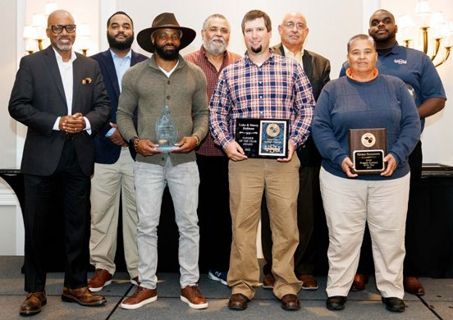
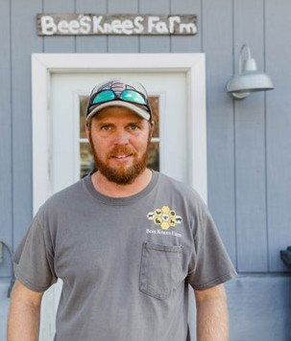
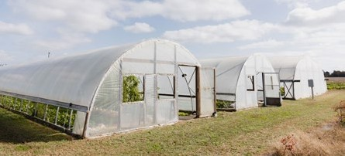
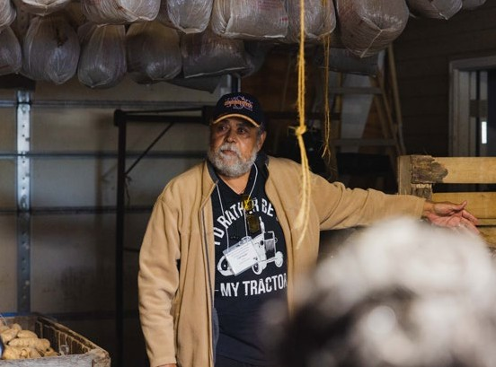
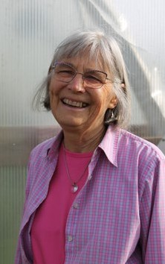

Charlie and Miriam Maloney, owners of Dayspring Farms, expressed their
A third-generation farmer who retired as both an Extension agent and an SFOP program assistant, Clif Slade, shared tips on growing sweet potatoes and elephant garlic. His approach
to farming is clear: “Responsible farming with profitable results!”
commitment to sustainable agriculture and the environment while providing for themselves and their community.

SFOP Quarterly Newsletter · Winter 2023 5

The Carver Center’s Harvest Nourishes the Community and Future Generations

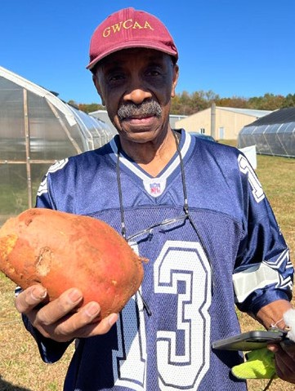
By Emily Oaks*

A bustle of activity animated fields in the shadow of Cedar Mountain while the fall sunshine smiled upon dozens of volunteers harvesting sweet potatoes, peanuts and cotton at Culpeper County’s Carver Center.
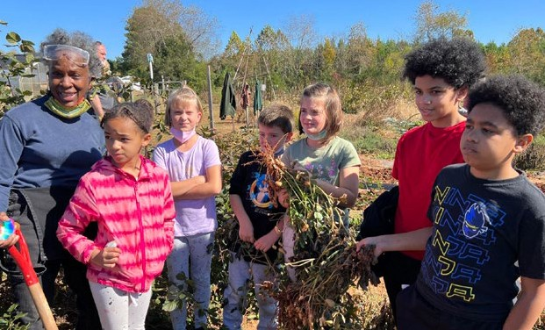
Minority and Veteran Farmers of the Piedmont, with members from Culpeper, Orange, Madison and
The three siblings traveled all the way from Maryland to help.
Sarah Morton, MVFP board member and director of workforce development for Virginia Career Works, said the involvement of youngsters is critical for

Rappahannock counties, grew the crops in honor of George Washington Carver, the namesake of the former regional high school—now the Carver Center—that served African American students during segregation.

MVFP volunteer Sheila Jackson demonstrated how to use a pitchfork to gently loosen a peanut plant, lift it from the soil and reveal the nuts in its root system.

Under Jackson’s supervision, nine-year-old Drew Stephens carefully dug around a plant until his brother, Shawn,12, and sister,
Savannah, 8, helped pull the plant out of the ground.

“It’s really cool to see the peanuts,” said, Shawn as the black soil fell away from the light brown shells.

farming. “These kids are the next generation of the agrarian workforce,” she said. “Seeing them out here learning about growing and harvesting peanuts, sweet potatoes and cotton creates a community of unity.”

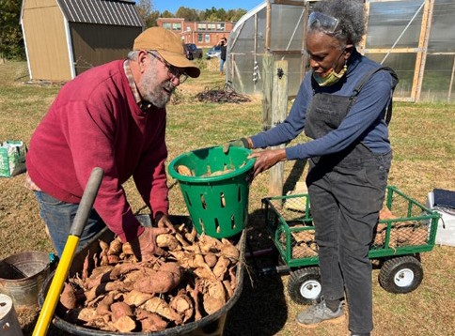
MVFP recently received a $25,000 grant from the PATH Foundation to help the nonprofit agricultural group in its community-building efforts.

The organization works with Empowering Culpeper to distribute food grown by MVFP farmers to those in need. MVFP also worked with Ebenezer Baptist Church in Charlottesville to source holiday boxes from local farmers.

Jackson said the second annual MVFP harvest yielded more than 458 pounds of sweet potatoes and 95 pounds of peanuts. Harvest
volunteers were invited to take home a portion of the food. The remainder went to local food banks or the
free clinic.

“It was a great success!” Jackson said. “Thank you to all who helped in any way!”

For more information see mvfpva.org, or gwcrhsaa.org.

6 SFOP Quarterly Newsletter · Winter 2023

Chase City Community Gardens Flourish
Vacant lots are transformed into beautiful, functional spaces.

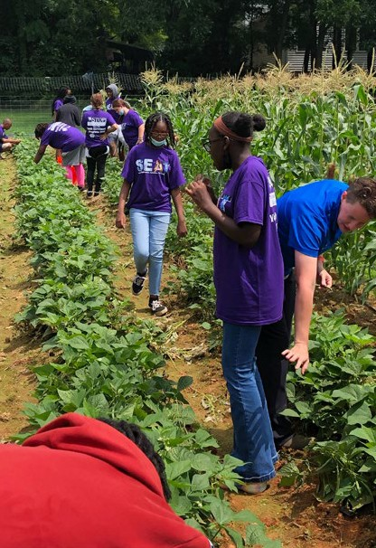
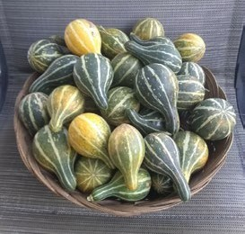
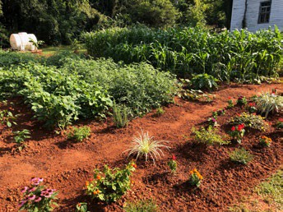
Like a plant that puts out runners multiplies its fruitfulness, so one person with vision, passion and expertise, has the ability to reach out, develop supporters and make a huge difference in a community.
Wanda Johnson is such an individual.

This Small Farm Outreach Program state program assistant yearned to transform derelict vacant lots in Chase City, Mecklenburg County,
Virginia, into valuable community gardens that provide fresh seasonal herbs and vegetables to neighbors, beautify the area and foster pride and enjoyment. But, she needed help.
Partnering with the Town of Chase City, Virginia State University College of Agriculture, Virginia
Cooperative Extension SFOP, and colleagues from VSU and Virginia Tech, made her dream a reality. Her efforts also rapidly earned support from local individuals and businesses.
Dusty Forbes, town manager not only identified suitable town properties but also spoke with
property owners with green spaces.

Fifth Street Community Gardens
A town-owned double lot on Fifth Street was selected for the first community garden. Leonard Elam, SFOP regional program assistant, and VSU Randolph Farm staff helped plan, prepare and plant the garden with help from several community members.
During the summer harvest, residents were invited to take some of the corn, tomatoes, green beans, peas, sweet potatoes, peppers, gourds, flowers and herbs. Passers-by smiled, waved, honked horns or stopped to offer positive comments. 93-year-

old William Carter, a veteran and former barbershop owner, volunteered to give the garden a professional edge.

As the summer faded, organic material was added to the soil to nourish it, including spent plants from the garden. Fall plantings included purple & green kale, turnip greens, mustard greens, Florida broadleaf mustards, collards, purple & green cabbage, Brussels sprouts, Bok choy, cauliflower and broccoli.

Mary Wood Food Forest
The Mary Wood Food Forest was established on a double lot donated to the town in honor of its namesake.
A food forest is a low-maintenance, sustainable, plant-based food
production and agroforestry system based on woodland ecosystems that takes several years to become well
established. Designed to mimic nature, it consists of edible plants, such as fruit and nut trees, shrubs, herbs, vines, mushrooms, root vegetables, and perennial vegetables. A list of potential native plants is under consideration.

Community support is tremendous. Asplundh Tree Service donated a large quantity of wood .chips.
Lumber, sawdust, mulch, logs, cardboard boxes and pallets were also donated. These items will be useful in establishing
the food forest, developing a
permaculture design, building raised beds, and growing mushrooms.
Colleagues from VSU and SFOP will conduct demonstrations of the processes required to
ensure this community food forest is beautiful and bountiful.
Johnson expressed appreciation for everyone who has supported these projects.
“The community, including individuals, local officials and businesses, enabled the establishment of this garden and food forest in Chase City,” said Johnson. “We always welcome ideas, partnerships, and donations.”
For more information, to volunteer or to donate, contact Wanda Johnson at wjohnson@vsu.edu or 434-632-9701.

SFOP Quarterly Newsletter · Winter 2023 7
Winter Ag Tips from SFOP Program Assistants

Livestock / Fish / Poultry
The season for lambing and kidding is upon us, and small ruminant producers should remember these fundamental reminders for success:
- Prepare your lambing/kidding facilities. Ensure they are clean and dry.
- Have all essential lambing/ kidding supplies available— including colostrum.
- Watch for birthing problems and know when to intervene, as well as when to call your veterinarian.
- Monitor the general health of the lambs and kids. Make sure kids are getting ample milk.
- Watch to make sure the feeding area is safe to prevent kids and lambs from being trampled.
- Place feed hay in different areas in the pasture to help distribute the nutrients found in manure.


General Farming
What is the AgriStress Helpline?
The AgriStress HelplineSM is a free, confidential 24/7 of agriculture, forestry, and fishing workers, and crisis-support line that you can call or text for mental- can provide you with state-specific agricultural and health support. Interpretation services are provided in health resources.
160 languages.
Good health, including mental health, is a key factor
How does the AgriStress Helpline differ from 988? in your ability to earn a living and enjoy life. If you’re Both the AgriStress Helpline and 988 offer quality overwhelmed, having trouble sleeping or showing other suicide or crisis services; however, the AgriStress signs of mental distress, get the confidential help you crisis specialists have extra training. They understand need from people you can trust:
the culture, values, stressors, and lived experiences
Call or text the AgriStress Helpline at 833-897-2474.
- Follow your nutrient-management plan’s recommended split- application rates for your crops during the growing season. By providing a small, steady supply of nutrients at the right time, you’ll meet your crops’ needs and reduce nutrient losses.

- Participate in an ag workshop and develop a network with other farmers.

Planning / Preparing / Planting
- Prepare your seed beds.
- Plant a good cover crop to add nutrients to the soil and help prevent soil erosion.
- Obtain quotes now for next year’s fertilizer, plants and seed. Booking early usually results in lower prices and better selections of seeds and plants.
- Assess and address your soil’s nutrient needs now for the spring growing season.
  - Take soil samples of each of your growing areas.
  - Soil test results that are up to three years old may be used to develop a crop-specific nutrient-management plan.

  - Remember that pelletized lime activates in four to five months.

Business Management

Profits
- If you are growing crops for grain, check the futures market to determine if prices are good for next year’s delivery.
- Check to see if seed companies are still having year-end sales before supplies run out.

Insurance
- Although election changes for 2023 are optional, producers must enroll through assigned contracts each year. Agriculture
Risk Coverage (ARC) and Price Loss Coverage. Through the USDA Farm Service Agency, producers can now do the following:
- Make 2023 crop-year elections.
- Enroll in Agriculture Risk Coverage and Price Loss Coverage programs.

8 SFOP Quarterly Newsletter · Winter 2023

Agribusiness Production & Financial Management Course Goes Online
Due to the amount of interest in our Agribusiness Production & Financial Management Class, we will be offering this course online. You will learn about financial management, balance sheets, cash flow, income statements and more.
Those who successfully complete the course, which consists of seven modules plus quizzes, qualify to apply for an FSA loan since VSU is licensed to conduct this FSA pre-requisite training.
“We look forward to this opportunity to provide our farmers with the education they need in a format that may be more convenient and cost-effective,” said Herbert Brown Jr., assistant director of SFOP.
This course will be launched in early spring, so keep an eye out for more details.


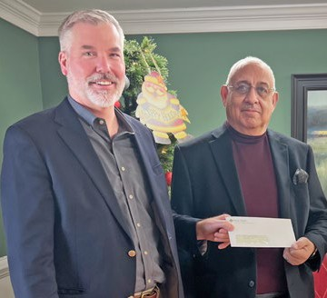
The Virginia Agriculture Mobile Education Unit is now accepting reservations
for March 2023 and beyond

The Virginia Agriculture Mobile Education Unit is an
interactive educational tool that showcases the Commonwealth’s largest private industry— agriculture and forestry—while demonstrating the valuable
role it plays in our daily lives.
Ideal for K-12 students, and adults across the
Commonwealth, this agriculture classroom will be a welcome addition to your school, business or community event.
Reservations are currently free and must be made six months prior to the scheduled event. To reserve the unit for August 2023 and beyond, call 804-524-2551 or email coamobileedu@vsu.edu.

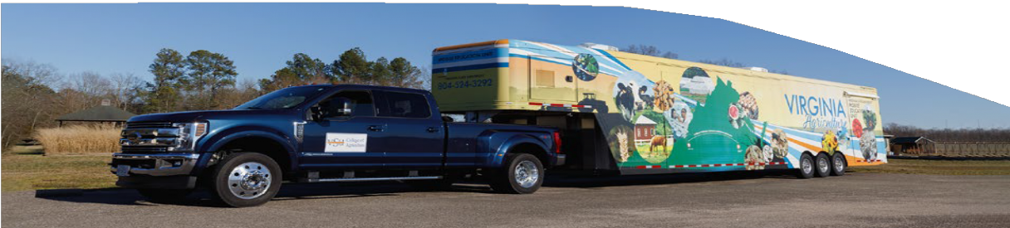
On behalf of Colonial Farm Credit, its president, Paul Franklin, presents an annual donation to SFOP Director William Crutchfield to support SFOP’s efforts.

SFOP Quarterly Newsletter · Winter 2023 9

SFOP Workshops: February–March 2023*
Date | Workshop | Time | Location | Program Assistant | Limit | Cost
2/9/23 | Changes to Livestock Antibiotic Regulations in 2023 | 7–8 pm | Virtual | Mandy Fletcher
2/14/23 | Preparation for a Successful Growing Season—Hispanic Farmers | 10 am–1 pm | VSU Randolph Farm Pavilion, 4415 River Rd, Petersburg, VA 23803 | Leonel Castillo & Tammy Holler | 10
2/14/23 | USDA Information Session | 10 am– noon | Charlotte County, VIrginia | Leonard Elam
2/15/23 | USDA Information Session | 1:30–3:30  pm | Virtual | Dennis Hatch
2/15/23 | Drones In Agriculture | 10 am– noon | Mecklenburg County Extension Office, 311 Washington  Street, Boydton, VA, 23924 | Leonard Elam & Leonel Castillo
2/15/23 | QuickBooks for Farmers | 10 am– noon | Virtual | Herbert Brown | 20
2/15/23 | DCR Information Session | 10 am–  12:30 pm | Virtual | Derrick Cladd
2/16/23 | Preparing A One-Page Business Plan | 10 am– noon | Prince Edward County Extension Office, 100 Dominion Drive Farmville, VA, 23901 | Leonard Elam & James Gibson | 20
2/21/23 | Small Farm Orientation | 9–11 am | Virtual | Herbert Brown | 40
2/21/23 | Pruning Fruit Trees for Beginners | 10 am– noon | Unionville, Virginia | Roland Terrell & Leonard Elam
2/23/23 | Taste of Farming—Sheep & Goat Production | 7–8:30 pm | Virtual | Mandy Fletcher
2/23/23 | Pruning Thornless Blackberry Canes | 10 am– noon | Mecklenburg County Extension Office, 311 Washington  Street, Boydton, VA, 23917 | Leonard Elam & Roland Terrell | 10
2/24/23 | Let's Get ready for your 2023 Farmers Market Display! | 12–1 pm | Virtual | Marilyn Estes
2/28/23 | Pruning Fruit Trees for Beginners | 10 am–1:30  pm | Salem, Virginia | Brent Noell | 10
3/1/23 | Planting and Caring for Spring Flowers: From Seeds and Starts to Beautiful Blooms | 10 am– noon | Virtual | Roland Terrell
3/2/23 | Prep for a Successful Growing Season | 10 am–1 pm | VSU Randolph Farm Pavilion, 4415 River Rd, Petersburg, VA 23803 | Derrick Cladd & Tammy Holler | 25

For more information and to register, visit www.ext.vsu.edu/calendar.

10 SFOP Quarterly Newsletter · Winter 2023

SFOP Workshops: February–March 2023*
Date | Workshop | Time | Location | Program Assistant | Limit | Cost
3/8/23 | Starting and Growing in Beekeeping | 9 am–12 pm | VSU Randolph Farm Pavilion, 4415 River Rd, Petersburg, VA 23803 | Dennis Hatch | 35
3/8/23 | Making Dollars and Sense Out of Backyard Poultry | 10 am– noon | Virtual | Leonard Elam
3/9/23 | DCR/Three Rivers Soil and Water Conservation District Information Session | noon–1:30 pm | Virtual | Dennis Hatch
3/9/23 | USDA Information Session | 10 am– noon | Virtual | Michael Carter Sr
3/11/23 | Small Engine Maintenance | 10 am–12  pm | VSU Agriculture Engineering Building, 101 Myster Macklin Street, Ettrick, VA | Roland Terrell | 20
3/14/23 | DCR Information Session | 6–8 pm | The APEX Center, 200 Apex Drive, Wytheville, VA 24382 | Brent Noell
3/15/23 | QuickBooks for Farmers | 10 am– noon | VSU Randolph Farm Pavilion, 4415 River Rd, Petersburg, VA 23803 | Herbert Brown | 20
3/16/23 | Preparation for a Successful Growing Season | 10 am– noon | Staunton River Memorial Library, 500 Washington Street, Altavista, VA, 24517 | Leonard Elam & Tammy Holler
3/21/23 | How to Bed Sweet Potatoes for Spring Slip Production | 10 am–  12:30 pm | Surry, Virginia | Dennis Hatch
3/21/23 | Small Farm Orientation | 9–11 am | Virtual | Herbert Brown | 40
3/21/23 | Novel Endophyte Tall Fescue Renovation Workshop | 8:30 am–4  pm | VSU Randolph Farm Pavilion, 4415 River Rd, Petersburg, VA 23803 | Tim Sexton |  | $40
3/21/23 | Drones In Agriculture | 10 am–1 pm | Carver Center, 9432 N James Madison Hwy, Rapidan, VA 22733 | Roland Terrell & Leonel Castillo | 40
3/23/23 | Small Ruminants: Wisdom for Weaning | 5–7:30 pm | Southwest VA Agricultural Research & Extension Center, 12326 VPI Farm Rd, Glade Spring, VA 24340 | Mandy Fletcher
3/29/23 | Wildlife Management | 9 am–3 pm | VSU Randolph Farm Pavilion, 4415 River Rd, Petersburg, VA 23803 | Derrick Cladd
3/30/23 | Get More From Your Milk | 1-4 pm | Alberta, Virginia | Marilyn Estes | 12

For more information and to register, visit www.ext.vsu.edu/calendar.

SFOP Quarterly Newsletter · Winter 2023 11
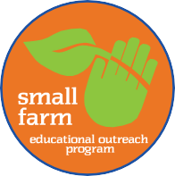
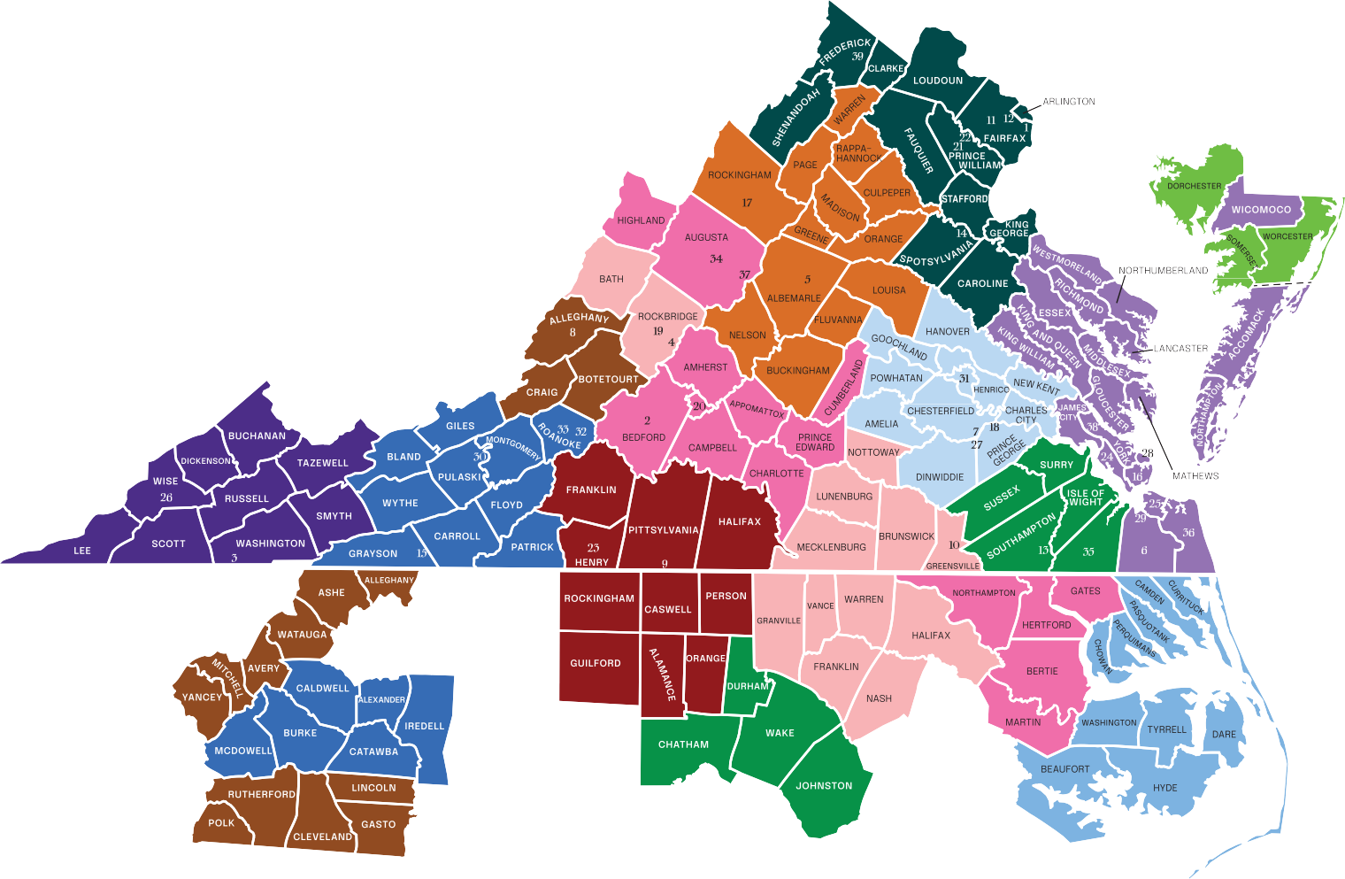
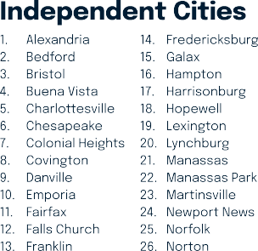
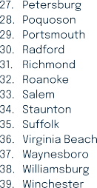
Contact Our Program Assistants

Regional Program Assistants*

Michael Carter Sr | 804-481-1163 | mcarter@vsu.edu | Brent Noell | 804-892-0140 | bnoell@vsu.edu
Leonard Elam | 804-894-3095 | lelam@vsu.edu | Dennis Hatch | 804-689-0410 | dhatch@vsu.edu
Marilyn Estes | 804-481-0485 | mestes@vsu.edu | Cliff Somerville | 804-892-4581 | csomerville@vsu.edu
Mandy Fletcher | 804-892-0108 | afletcher@vsu.edu | Roland Terrell | 804-892-4612 | rterrell@vsu.edu
James Gibson | 804-720-6826 | jegibson@vsu.edu

State Program Assistants James Edwards | 804-720-2588 | jtedwards@vsu.edu
Military Veteran, AgrAbility

Frederick Custis | 804-894-0218 | fcustis@vsu.edu
Agriculture Management Coordinator

Leonel Castillo | 804-731-0230 | lcastillo@vsu.edu
Hispanic Outreach, Drone Pilot

Derrick Cladd | 804-892-4489 | dcladd@vsu.edu
Beginning Farmers
Tammy Holler | 804-229-2730 | tholler@vsu.edu
Nutrient Management

Wanda Johnson | 434-632-9701 | wjohnson@vsu.edu
Community Gardens, Food Services

Grace Summers | 804-712-0093 | gsummers@vsu.edu
NRCS, SFOP High Tech Tunnel


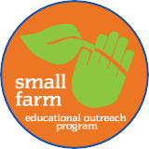
P.O. Box 9081
Virginia State University, VA 23806

NONPROFIT ORG
U.S. POSTAGE PAID
PETERSBURG, VA PERMIT NO. 46


Where Virginia’s small and beginning farmers and ranchers access comprehensive resources to help make their farm businesses profitable and sustainable.
vasmallfarm.org

Education & Training Resources · Diverse Models of Farm Production & Operation · Ag-Related News & Events · Federal, State & Local Agency Contacts Agro-Equipment Rental Programs · Expert Advice Online or by Phone
...and More
The Virginia Small Farm Resource Center is developed and supported by Virginia State University’s Small Farm Outreach Program.









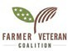

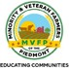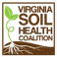

If you are a person with a disability and desire any assistive devices, services or other accommodations to participate in this activity, please contact the Small Farm Outreach Program office at smallfarm@vsu.edu or call 804-524-3292/TDD 800-828-1120 during business hours of 8 am. and 5 p.m. to discuss accommodations five days prior to the event.
Virginia Cooperative Extension is a partnership of Virginia Tech, Virginia State University, the U.S. Department of Agriculture and local governments. Its programs and employment are open to all, regardless of age, color, disability, gender, gender identity, gender expression, national origin, political affiliation, race, religion, sexual orientation, genetic information, military status, or any other basis protected by law.
8K 1/2023 ©2023 Virginia State University College of Agriculture

Attachment #3
NRCS REPORT
Virginia Soil & Water Conservation Board Meeting
March 23, 2023 • Hungry Mother State Park, Marion, Virginia

State Conservationist’s Highlights

- SWCD assistance is essential for us to be able to address our agency goals: equity in all programs, climate smart agriculture and forestry, urban agriculture efforts, diverse workforce and leveraging innovative partnerships.

- Inflation Reduction Act (IRA) provides $19.5 billion to NRCS over five years to support programs that yield climate change mitigation benefits. Please help Virginia NRCS promote this opportunity. The inflation reduction act translates into tons opportunities: for our landowners, conservation partners and our NRCS teams regarding staffing capacity, environmental benefits, research, opportunities for our agriculture and forestry sectors, benefits for the Chesapeake Bay watersheds, and certainly our state’s economy. Virginia received $2.5 million for EQIP-IRA and $4.3 million for CSP-IRA, application deadline for both is March 17, 2023. ACEP-WRE IRA has some priority areas in Virginia; these applications will compete nationally, application deadline is March 17, 2023.

- Locally Working Group guide is available and local coordination and collaboration is the key to this process.

- The Virginia Security Corridor Sentinel Landscapes Initiative – The Team completed and submitted a Tier 2 proposal to the Federal Coordinating Committee on February 17th. This is a partnership to meet military, working lands and waters, conservation, and economic development priorities in the Commonwealth of Virginia. Sentinel Landscapes is an initiative led by U.S. Dept. of Defense, U.S. Dept. of Interior, and U.S. Dept. of Agriculture. Additional key partners are the U.S. Forest Service and U.S. Fish & Wildlife Service.

- Virginia NRCS Conservation Innovation Grants (CIG): Priorities for FY 2023: $400K budget: Soil Health and Forestry Emphasis. The call for proposals will be out soon.

- Chesapeake Bay States’ Partnership Initiative – The National Office is currently assessing state needs under this initiative in FY22 we received $6.25 million; $1 million for EQIP, $500k for CSP, and $4.75 million for ACEP.

- Urban Agriculture Partnership – Ongoing urban agriculture efforts in the city of Richmond with the People’s Garden Initiative and our assessment for a potential urban agriculture office.

ASTC-Programs (ASTC-P)

EQIP, CSP, RCPP, VPA-HIP, CIG, TSP and Easement Programs
Field staff are currently managing 2,100 active conservation program contracts with our participants. These contracts represent $141 million in financial assistance to Virginia farmers on nearly 468,533 acres.

Environmental Quality Incentive Program (EQIP)
Received and ranked 1,031 EQIP applications. Applications are currently being evaluated for preapprovals. Secured $994,655 for funding the Joint Chiefs Eastern Divide Restoration Project. Received a total EQIP allocation of $22.18 million.

Conservation Stewardship Program (CSP)–Classic, Renewals & GCI
Obligated $7.42 million for 117 CSP renewals on 46,130 acres, a 41% increase in contracts obligated over FY22. Funded 14 CSP-GCI contracts for $39,280 (all applications submitted).

Regional Conservation Partnership Program (RCPP)
Currently managing 16 active contracts with total funding of $2 million covering 6,687.6 acres. Proposal announcement to be released soon.

Agricultural Conservation Easement Program (ACEP)
Received 9 ALE applications on 2,433 acres.

Conservation Innovation Grants (CIG)
Currently, finalizing State CIG proposal with $400k available to support the development of new tools, approaches, practices, and technologies to further natural resource conservation on private lands.

Engineering (SCE)

Staffing Updates
- NRCS Virginia will have the upcoming advertisements. Both positions will be in Richmond.
  - Hydraulics Engineer
  - Dam Safety Engineer

Dam Rehabilitation
- Beaver Creek 1
The Rivanna Water and Sewer Authority (RWSA) is overseeing the locally led planning effort and has retained Schnabel Engineering as its consultant. The final supplemental plan EA has been developed. The NRCS plan authorization process is ongoing.

Cherrystone Creek 1 and Cherrystone Creek 2A
Pittsylvania County is leading the locally led design effort for rehabilitating the structures. Pittsylvania County has retained Schnabel Engineering as its consultant. The design process is ongoing. The design is estimated to take 18 to 24 months.

Johns Creek 1
Funding has been secured for the rehabilitation design. Mountain Castles SWCD will be the sponsor for the locally led project. The agreement between NRCS and the SWCD is in progress.

Emergency Watershed Protection (EWP)
- NRCS is providing disaster assistance to Buchanan County through the Emergency Watershed Protection Program (EWPP) for a rain event in the Hurley area on August 30 (estimated 6-8 inches). NRCS and Buchanan County completed damage survey reports (DSRs) for 4 county-identified sites. Funding for 3 eligible sites was received in mid-January 2022 and the EWP agreement was finalized on March 15, 2022. Buchanan County has submitted final designs for the sites. Construction is anticipated to begin in March 2023 and will be completed by the end of June.

State Resource Conservationist (SRC)

Chris Bradshaw is currently acting State Resource Conservationist for Virginia for 120 days or until the position is filled.

NRCS is working with DCR to coordinate a RUSLE 2 Training session for SWCDs for 2023. Logistics and the schedule are being discussed.

Technical Tools (Field Office Technical Guide)
Continue to maintain the Virginia Field Office Technical Guide (FOTG) as a repository of technical resources and references to include conservation practice standards, technical notes, planning criteria, resource concerns, conservation practice physical effects, cost lists and the Virginia Plant Establishment Guide.

- Released Virginia Bulletin 180-23-4, which provides updates about the Conservation Reserve Program

Training to Field Staff
- Continue the use of SRC webinars in place of tradition in-person meetings, allowing us to disseminate information quickly and efficiently to field staff:
  - January 18, 2023 – FY2023 CPA, DIA, CEMA Updates
  - February 8, 2023 – FSA Compliance Reviews – Survey Results – Lessons learned in 2022
  - February 15, 2023 – FY23 CSP Classic Webinar – Programs Staff
  - February 22, 2023 – FSA Compliance Reviews – FY2023 Training for Staff
  - March 1, 2023 – Inflation Reduction Act Webinar – Programs Staff
- RUSLE2 Office Hours – Mondays 2:00-4:00 pm – hosted 7 events since January 9, 2023.
- Staff/Partnership Trainings
  - January 24- 27, 2023 – Virginia Forage & Grassland Council Winter Conferences
  - February 7, 2023 – Soil Health & Corn Nutrient Mgt Presentation to DCR, Charlottesville
  - February 23, 2023 – CD/CART training for NRCS employees, virtual
- SRC Staff Training/Outreach Events
  - January 10, 2023 – Four Rivers VCE Ag Conference, New Kent
  - January 10, 2023 – Tri-County VCE Crop Production Conference, Prince George
  - January 17 & 19, 2023 – Virginia Crop Production Association Crop Summit, Richmond
  - February 14, 2023 – Southside SWCD Program Outreach Meeting, Keysville
  - February 14, 2023 – Overview of Grassland in Virginia, virtual with Virginia Tech
  - February 15, 2023 – Virginia Cotton Growers Association, Franklin
  - February 16, 2023 –VCE Central Virginia Women in Agriculture Gathering, Syria
  - February 21, 2023 – Virginia No-Till Alliance Conference, Harrisonburg

- SRC Staff Training – In-the-Field-Training
  - February 28, 2023 – FSA Compliance Review Training for reviewers – Tappahannock
  - March 2, 2023 – FSA Compliance Review Training for reviewers – Fairfield

Customer Service and Outreach

- Partnership meeting with Virginia Tech and Appalachian Sustainable Development to plan for 3 Agroforestry train-the-trainer events later in the fiscal year.

- Partnership meeting and discussion with Virginia Department of Forestry regarding biochar initiatives, opportunities, and discussion of the soil carbon amendment standard.

- Partnership meeting with DCR to discuss the ongoing collaborative Data Sharing Agreement.

- Partnership meetings with FSA to keep communication ongoing regarding Compliance Issues

- Partnership meetings with the Virginia Poultry Disease Task Force to monitor and manage the two HPAI outbreaks in Western Virginia.

- Internal collaborative meetings between SRC staff and GIS to develop training for ARCs to use Survey 123 software for more effective and efficient data capture for Ecological Sciences Spot Checks.

- Partnership meeting with USFWS to begin discussions about consultation and the Programmatic Agreement.

- Partnership meeting with DU to share information and begin discussion of ways to further collaborate in Virginia.

State Soil Scientist (SSS)

Soil Survey Update
- The Sweet Briar College has requested NRCS assistance with using our ground penetrating radar equipment to assist in agriculture projects with locating water lines and the depths of those waterlines. A date has not been planned as of 2/15/2023.

- A letter of collaboration has been provided to Virginia Tech for a grant request to the Virginia Wine Board to study soil health in viticulture. The project, “How does management affect soil health in Virginia vineyards,” has the potential to help us make more informed land management decisions by addressing soil health indicators in differently managed parts of commercial vineyards (under- vines, row middles, tire tracks, and undisturbed adjacent soil), and develop standards and best practices for soil health testing in Virginia vineyards to share with growers and commercial soil health testing labs.

- HB-894 NRCS partnership with Virginia Tech extension and others released the Virginia Land and Energy Navigator (VaLEN) https://valen.ext.vt.edu/ A collaborative effort, the Virginia Land and Energy Navigator (VaLEN) brings together GIS information related to prime farm and forestland,land conservation, electric utility infrastructure, and other themes to support land use planning and decision-making at the local level.

- Soil Tidbits will continue being sent to SWCD employees bi-weekly.

- An inflatable soil tunnel has been acquired by NRCS. Although we are currently gathering additional equipment needed to use it, other states have one and below is a picture.
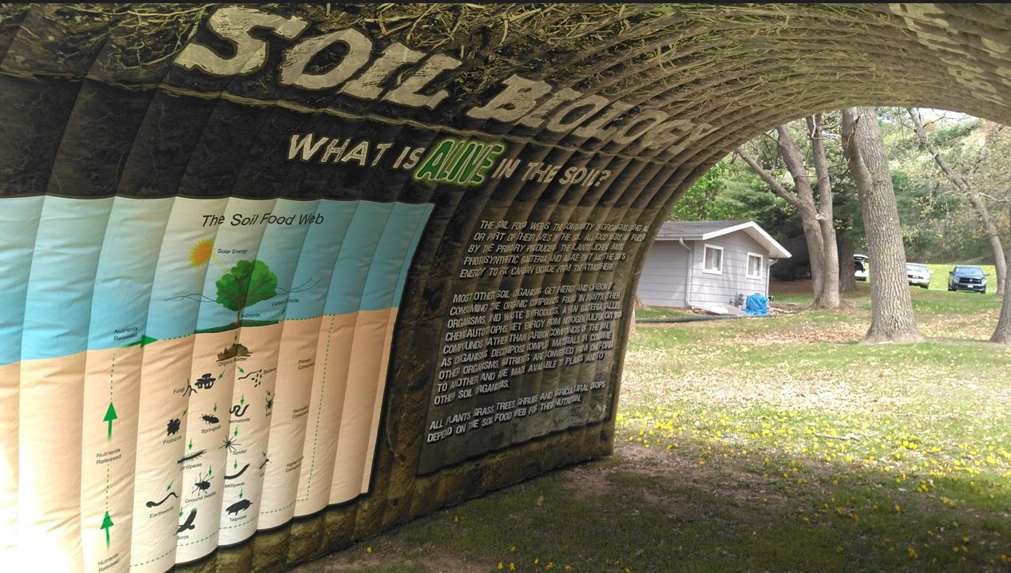
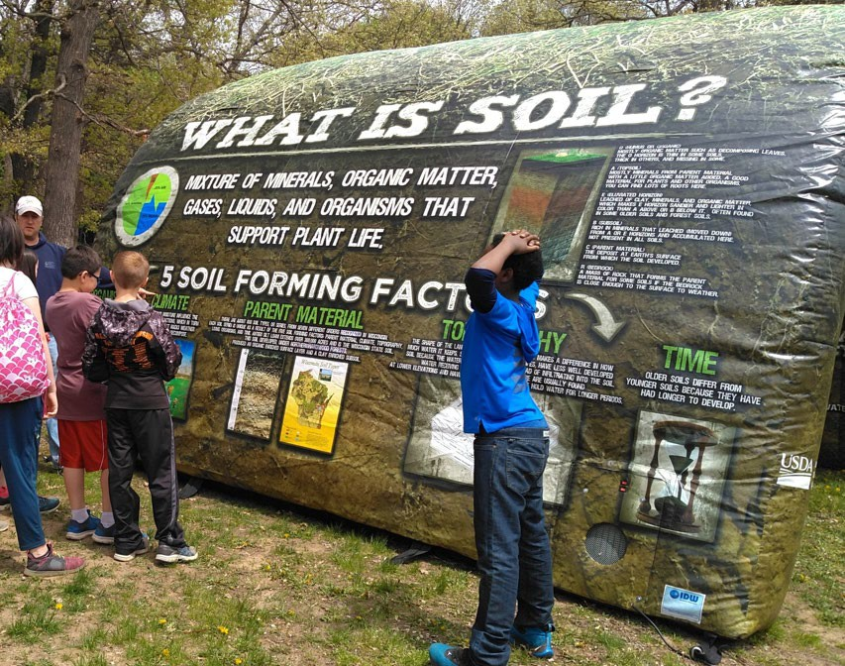

Lidar-
Current partnership funding discussions are ongoing for new Lidar acquisition of Cities of Virginia Beach and Chesapeake, Hampton Roads, Portsmouth, and possibly Norfolk and Poquoson. This possible new acquisition would include tide coordination at a QL2+ quality. Funding hasn’t been secured as of 2/15/2023.
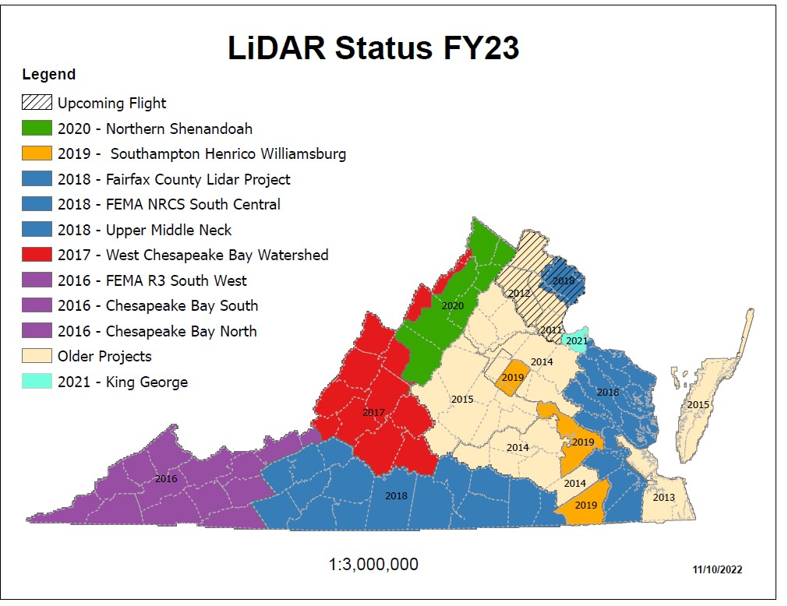
The annual NRI grazing land field data collection training is set for the May timeframe. All 768 segments of the LDSI NRI were completed by the January 30 due date.

Partnerships & Initiatives (P&I)

Peoples Gardens
Existing FY22 Agreements
- Fairfield Middle School
- Richmond Alternative School Proposed FY23 Agreements
- City of Richmond ($75,000)
  - Supports 25 Richmond Grows Gardens Sites and 5-7 additional community garden sites.
- Groundworks RVA ($25,000)
  - The Hillside Micro Farm and Community Space has the goal of providing food and learning opportunities for neighbors in the Hillside Community. The funds from the People’s Garden Initiative will be used to build-out both the farm and community space aspects of this project.
- Fit4Kids ($25,000)
  - Partners with 24 Elementary/Middle schools throughout the Richmond Metro area to establish gardens, educate children, and engage community members in urban agriculture.
- Kinfolks ($25,000)
  - TBD

Urban Office (Richmond)

- Urban Conservationist (2023) – Job announcement that was posted January 24, 2023, to Thursday, February 2, 2023. Waiting of certificates from HR.

- Working with FPAC leasing, FSA, and local partners on physical space.

Notice of Funding Opportunity for Technical Assistance
***Not out yet, hopefully in next 30 days***
Potential availability of funding for the purpose of leveraging NRCS resources to encourage collaboration with partners in providing strategic conservation delivery assistance and/or provide tools or data that enhance the ability of the agency to support conservation. The overall intent is to solicit partnerships to help enhance the implementation of key conservation objectives and priorities:
- Provide technical assistance in the delivery, development, promotion, and support of soil, water and wildlife conservation programs to Virginia’s farmers, ranchers, and landowners,
- Support delivery of Climate Smart Agriculture and Forestry conservation practices and show quantifiable carbon sequestration and/or greenhouse gas reductions,
- Reduce barriers to programs and improve support to underserved farmers, ranchers, and landowners.

Tribal
In the planning phase for 2023 Tribal Summit this fall focusing on State Recognized Tribes.
Attachment #4
VCE Report to the Virginia Soil and Water Conservation Board

March 2023

A few programmatic highlights from Agriculture and Natural Resources Extension Agents in SW Virginia:

Beef cattle are the major agricultural commodity of Southwest Virginia. Although beef cow numbers exceed 64,000 in the counties of Russell, Scott, Smyth, and Washington, the average herd size is 29 cows. Unlike large beef operations that command premiums in the marketplace for uniformity, small producers lack the ability to package groups of animals with similar features. Given this fact, small producers are unable to realize the maximum value for their products. With the sales of livestock in this area over $125 million, advisory groups (Extension Leadership Councils, Cattlemen’s Associations, Farm Bureau, etc.) and numerous Situation Analyses have directed agents programming efforts toward beef cattle production and marketing. By coordinating an effort to get small producers to work together, Extension Agents have changed the beef business in Southwest Virginia. In 2021 participants received a total of $871,455 in premiums ($106.78 per VQA calf sold) as gross cash receipts for the 8,161 animals exceeded $7.8 million. With 113 tractor-trailer loads of VQA calves sold, revenues were 12.5% greater than values received at traditional state-graded livestock sales (as reported by the Virginia Department of Agriculture). Reaching beyond the original four counties, participants are drawn from 10 Virginia counties, Tennessee, and North Carolina. With 84,541 animals sold (1,138 tractor trailer loads) since 2005, producers have added over $7.9 million to the gross livestock sales (+$6,967 per load).

Through the project “FRESH START: On-Farm Produce Safety Investments from Farm to Market”, the Virginia Pumpkin Growers’ Association (VPGA) in collaboration and with support from the Virginia Cooperative Extension (VCE) focuses on addressing investment gaps within the fresh produce sector and increasing the capacity of fresh produce growers to continually meet the standards and requirements in food safety, particularly with USDA’s Good Agricultural Practices (GAP) standards. The project also supports producers in complying with best practices in food safety which will ensure safe food products in the market, increase accessibility of nutritious produce, protect consumers’ health, build buyer and consumer trust, enhance produce freshness and quality, and benefit the produce sector. The Project Manager wrote and received a $508,000 grant from the Tobacco Region Revitalization Commission to fund this effort. Fresh Start was launched in January 2022 and will be implemented for at least two years, and could go to five years if needed. The projected reach is 100 fresh produce growers. In the 12 months that the project has been underway 25 individuals have been trained and 10 farms have had applications approved. Producers have spent $165,983.02 in matching funds and received $15,000 in cost-share reimbursements from the grant. This project is managed by Ashley Edwards, ANR Extension Agent in the VCE-Carroll County Office.

The Improving Genetics, Health, and Management of Small Ruminants in SWVA project received two rounds of funding from TRRC totaling $514,880. This program provides cost share incentives for small ruminant producers in the entire SWVA region to assist with genetic improvements to herds as well as equipment and facility needs required for effective herd management. Carried out in conjunction with the Abingdon Feeder Cattle Association (AFCA), the program is projected to reach about 70 producers for first phase and 98 producers for the second phase (168 total). In the eight months that the project has been underway to date producers have invested $272,431.70 in operational improvements and received $73,723.62 in cost-share. Cost share as a percentage of the investment is 27.06% and producers have invested $3.70 for every dollar of cost-share received. This program is managed by Phil Blevins, ANR Extension Agent in the VCE-Washington County Office.

Here is a Youth in Agriculture Video courtesy of Crystal Peek, 4-H/Youth Development Extension Agent in the VCE-Washington County Office: https://vimeo.com/807081199?fbclid=IwAR3RB7QJPg0cJzEVbk5q6qlldcEsLdIybHYyxQq1-Me-55AEQ2SZKytz2wE

