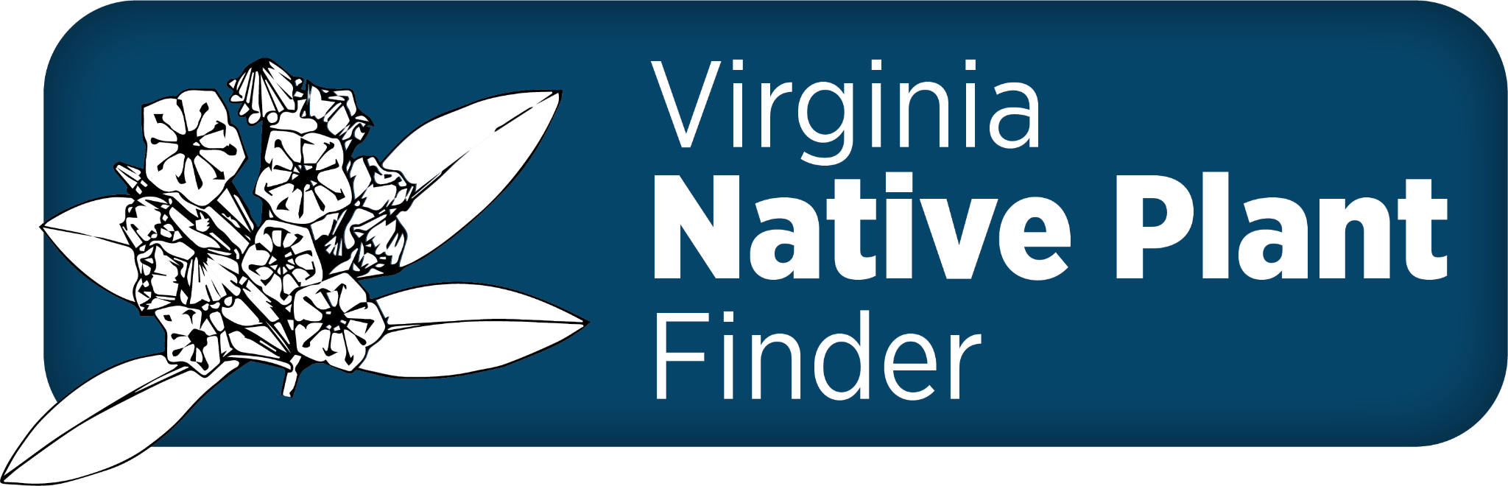

DCR’s Virginia Native Plant Finder

social media kit
Our toolkit provides you with information to share this update with your network. Please contact DCR’s senior PR and marketing specialist Emi Endo (emi.endo@dcr.virginia.gov / 804-786-8442) with any questions.
Please tag the Virginia Department of Conservation & Recreation’s accounts when you post.
- Facebook: facebook.com/VirginiaDCR/
- Instagram: @dcrvirginia
- X (aka Twitter): @VirginiaDCR
- LinkedIn: linkedin.com/company/virginia-dcr/
Facebook copy
🔍 Whether you’re planning a small backyard garden or a large pollinator-friendly solar installation, the improved Virginia Native Plant Finder can help you identify the right plant for the right place. Use this free, online tool to choose the perfect native species to transform your design into a thriving reality!
New features include:
🌱 “Live Plant Available” and “Commercial Seed Available” links to plant providers
📍 Filtering by county
📁 Downloading results as a CSV file
Check it out at https://www.dcr.virginia.gov/natural-heritage/native-plants-finder
Click here to download image options – zip file

Instagram copy
Did you know, there’s a free, online tool to help you choose the perfect native species to plant? 🔍 And it just got an upgrade! The Virginia Native Plant Finder has improved function to better serve projects from small backyard gardeners to large pollinator-friendly solar installations.
New features include:
🌱 “Live Plant Available” and “Commercial Seed Available” links to plant providers
📍 Filtering by county
📁 Downloading results as a CSV file
Check it out on @dcrvirginia’s website (click their link in bio).
#DCRvirginia #PlantNatives #VirginiaNativePlants #FloraofVirginia #NativePlants
Click here to download image options for a feed post AND/OR for a story zip files
X (aka Twitter) copy
Virginians: Looking for the right plant for the right place? 🔍 Well good news, the latest version of @VirginiaDCR's free Native Plant Finder gives specific recs based on your habitat (light/moisture/plant types) and even locality!
➡️ https://www.dcr.virginia.gov/natural-heritage/native-plants-finder
#plantnatives
Click here to download image options – zip file
LinkedIn copy
Whether you’re planning a small backyard garden or a large pollinator-friendly solar installation, the improved Virginia Native Plant Finder can help you identify the right plant for the right place. ➡️ https://www.dcr.virginia.gov/natural-heritage/native-plants-finder Use this free, online tool to choose the perfect native species to transform your design into a thriving reality!
New features include: “Live Plant Available” and “Commercial Seed Available” links to plant providers; filtering by county and downloading results as a CSV file.
Check it out!
#NativePlants #pollinators #Virginia #PlantNatives
Click here to download image options – zip file

