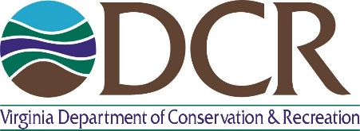
VA Floodplain Management Program
COURSE ANNOUNCEMENT

COURSE CODE | L-273
COURSE TITLE | Managing Floodplain Development through the National Flood Insurance  Program (NFIP)
COURSE LOCATION | King & Queen Public Library, 396 Newtown Rd., St. Stephens Church, VA 23148  Training Room
COURSE DATES | April 24 to April 27, 2017; CFM Exam on April 28, 2017.
COURSE TIMES | Monday through Thursday 9:30 AM – 5:00 PM  CFM exam Friday 10:00 AM – 1:00 PM
COURSE DESCRIPTION | This EMI course is designed to provide an organized training opportunity for local officials responsible for administering their local floodplain management ordinance. The course will focus on the NFIP and concepts of floodplain management, maps and studies, ordinance administration, and the relationship between floodplain management and flood insurance.
COURSE PREP | Participants must complete the following online tutorials at http://www.fema.gov/online-tutorials (under “Other Tutorials” tab)  • Flood Insurance Rate Map tutorial  • Flood Insurance Studies tutorial
Why take this course? | Since local communities plan for, determine and supervise land use, implementation of the NFIP is done at the local level. The course will give the local floodplain manager an overview of the NFIP, and assist them with their day-to-day tasks. VA DCR is hosting this course to provide jurisdictions with the training needed to maintain a strong floodplain management program.  Funding for the training is being provided by FEMA.
INSTRUCTORS | This course will be taught by EMI trained instructors from FEMA Region III. VA DCR Floodplain Program staff will supplement the training.
TARGET AUDIENCE/DISCIPLINE | Local officials responsible for administering local floodplain management ordinances. The course is limited to 30 participants. Preference will be given to community floodplain managers.
CECs | This class can be submitted to the Association of State Floodplain  Managers (ASFPM) for 12 core Certified Floodplain Manager (CFM) continuing education credits.
COST | Free. Lunch will be on your own.
Certified Floodplain  Manager Exam | The CFM exam will be at 10:00 AM on Friday, April 28, 2017. The CFM certification program is provided by ASFPM. For more information about the program or to register/pay for the exam, visit the website at www.floods.org.

If you wish to register for this class, please fill out the attached training application and mail or fax it to the address at the bottom. If you have any further questions, please contact Charley Banks at 804-371-6135 or charley.banks@dcr.virginia.gov
Confirmations for training will be sent via email when possible.

COURSE CODE | L-273
COURSE TITLE | Managing Floodplain Development through the National Flood Insurance Program (NFIP)
COURSE LOCATION | King & Queen Public Library, 396 Newtown Rd., St. Stephens Church, VA 23148
COURSE DATES | April 24 to April 27, 2017
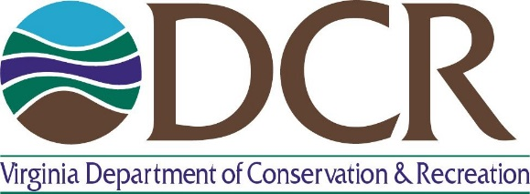

Virginia Department of Conservation and Recreation
TRAINING APPLICATION FORM

Name (Last, First)
Current Position/Title:
Jurisdiction (Specify city/county or choose from the following: State Agency, Federal Agency, or Private Organization):
Mailing Address: |  |  |  |  | Phone (Work):
 |  |  |  |  | Phone (alternate):
 |  |  |  |  | Fax Number:
Email Address:
Discipline:
 |  | Floodplain Manager  Code Enforcement/Inspection  Planning  Municipal Manager  Public Works |  | Emergency Management Private Consultant Community Official Engineering  Other (Please Specify):
Briefly describe your activities/responsibilities as they relate to the course
Do you have any disabilities (including special allergies or medical disabilities) which would require special assistance during your attendance at the training course? If so, please describe:
I certify that the information recorded on this application is correct.
Applicant Signature: |  |  |  |  |  | Date:
TO APPLY, PLEASE EMAIL, MAIL, OR FAX THIS APPLICATION TO:
Virginia Department of Conservation & Recreation
Attention: Charley Banks
600 East Main Street, 4th Floor
Richmond, VA 23219
Phone Number: 804-371-6135
Fax Number: 804-371-2630
charley.banks@dcr.virginia.gov

