NOTICE OF FUNDING OPPORTUNITY AND FUNDING MANUAL
RESILIENT VIRGINIA REVOLVING FUND
SOUTHWEST VIRGINIA RESILIENT RECOVERY AND REBUILDING
Overview
In accordance with § 10.1-603.29 of the Code of Virginia, the Department of Conservation and Recreation (the “Department”) and the Virginia Resources Authority (the “Authority”) is providing this Notice of Funding Opportunity (“Notice”) and Funding Manual for the Resilient Virginia Revolving Fund (Fund) to solicit public feedback and to provide general guidance regarding the policies, criteria, conditions, and procedures for determining project eligibility and awarding grants and loans from the Fund. The Department anticipates that it will provide additional and/or revised guidance at the opening of the funding round.
The Fund was established in 2022 by the General Assembly of Virginia: §§ 62.1-199 and 62.1-203 of the Code of Virginia were amended and reenacted and Chapter 6 of Title 10.1 10.1-603.28 through 10.1-603.40 of the Code of Virginia was amended.
Per the Code of Virginia, the Fund is authorized to provide grants and loans to local governments for the following flood resilience activities:
(i) home upgrades for resilience purposes, home buyouts and demolition necessary for the construction of mitigation or resilience projects, relocations, and buyout assistance for homes, all including multifamily units;
(ii) gap funding related to buyouts in order to move residents out of floodplain hazard areas and restore or enhance the natural flood mitigation capacity of functioning floodplains;
(iii) assistance to low-income and moderate-income homeowners to help lower flood risk through structural and nonstructural mitigation projects, or other means;
(iv) hazard mitigation and infrastructure improvement projects for resilience purposes;
(v) projects identified in the Virginia Flood Protection Master Plan or the Virginia Coastal Resilience Master Plan; and
(vi) to a local government that has developed a funding program to provide low-interest loans or grants to any persons of the Commonwealth eligible for projects for resilience purposes.
The purpose of this round is exclusively to provide funds for the resilient rebuilding of communities that have been impacted by Disaster Events, as those are defined below.
Important definitions and other statutory information regarding the Fund can be found in §10.1-603.28 et seq of the Code of Virginia.
Eligible Applicants
Pursuant to § 10.1-603.29 of the Code of Virginia, the Department is required to give “additional weight… to those projects that are located in a locality designated as having a very low community resilience rating under a standard adopted by the Department.” For the purposes of this round, the Department considers any local government that is listed, or lies within the boundaries of those listed, in the respective declarations for one or both Disaster Events, as those are defined in this Notice. A list of these local governments is contained in Appendix A.
“Disaster Event” means one or both of the following:
1. Tropical Storm Helene, being a disaster occurring on or after September 25, 2024, but before October 3, 2024, and subject to a Major Disaster Declaration (FEMA-4831-DR) issued by President Biden on October 1, 2024, and
2. The storms occurring during the State of Emergency declared by Governor Youngkin on February 10, 2025, including, without limitation the heavy rains occurring on or around February 15 and 16, 2025.
Only eligible local governments may apply for and receive awards directly from the Fund. However, eligible applicants may subsequently award funds for these purposes to persons, as that term is defined in § 1-230 of the Code of Virginia. Eligible applicants may contract or provide subgrant agreements with public, private and non-profit organizations or entities to execute approved activities or projects.
Categories of Funding
The Department intends to make funds available for three categories of activities:
Category 1: Grants and loans to support the resilient rebuilding of communities.
Available Funding: $20,000,000
Eligible Activities:
- Removal of privately-owned hazardous structures within the regulatory floodway, and flood-proofing and reconstruction of certain location-dependent structures within the floodway and floodplain, such as privately owned access bridges, culverts, retaining walls, and other water control structures, in a more flood-resilient manner;

- Buyouts and demolition of structures in order to move residents out of floodplain and flood hazard areas and to restore or enhance the natural flood mitigation capacity of functioning floodplains;

- Relocation assistance for occupants following the buyout of primary residences, including multifamily units;

- Costs related to projects that provide flood hazard mitigation benefits or lower flood risk to buildings, including costs related to home or business upgrades for flood resilience purposes, mitigation reconstruction, accessory structure resilience measures, increased costs of compliance with regulatory requirements, or increased costs associated with the reconstruction of damaged structures in a more flood resilient manner;

- Post-flood debris removal and management measures; and

- Other projects and activities consistent with the statutory scope of the Fund.
Category 2: Grants and loans to support the resilient rebuilding of infrastructure.
Available Funding: $20,000,000
Eligible Activities:
- Projects related to the resilient rebuilding of public infrastructure that have not received an award of federal funds or where federal funding requires a match or is insufficient to complete the project.
Category 3: Loans to mobilize federal grants.
Available Funding: $20,000,000
Eligible Activities:
- Projects related to the resilient rebuilding of public infrastructure, for which an application for federal funding has been made and awarded.
Funds for this category will be established as a revolving line of credit at the Virginia Resources Authority and made available to eligible applicants who meet the criteria for this category as bridge loans to support eligible project costs. Funds shall be paid back to the line of credit as they are subsequently received by applicants from the relevant federal agency.

Collection of Applications, Evaluation, and Distribution of Funds
The Department intends for the Fund to work in tandem with related financial offerings made available by the Department of Housing and Community Development, the Virginia Department of Emergency Management, the Virginia Department of Environmental Quality, and others. With this in mind, the Department may elect to collect applications through one of these agencies or another third party, or through a process that the Department establishes.
The Department will begin accepting and considering applications on DATE and will accept applications through at least DATE, or until available funds are exhausted. (Dates will be established in the final Fund offering document)
The Department will evaluate applications in a manner prescribed by statute based on need, impact, cost-effectiveness, and other relevant criteria. Evaluation criteria will be published prior to the opening of the funding round. Applications will be collected and awarded on a rolling basis.
Grant funds will be provided to applicants on a reimbursement basis according to a schedule established by the Department.
General Provisions
Successful applicants will be required to enter into a Memorandum of Agreement (MOA) with the Department, the Authority, and other parties as may be appropriate. This MOA will include the amount of funding to be provided, the activities that are anticipated to be funded, and the duration of the period of performance, and other relevant agreements, requirements, and restrictions. In the case of a loan from the Fund, the applicant will be expected to enter into a loan agreement with VRA, as administrator of the Fund, which agreement will outline the conditions and requirements for loan closing as well as any ongoing financial and operating covenants. The loan will be evidenced by a debt instrument authorized and issued by the governing body of the applicant. Standard opinions of bond and borrower counsel will be required as a condition for loan closing.
The Department and the Authority reserve the right to provide funding at a level less than requested by the applicant, or to refuse to fund an applicant’s request.
The Department further reserves the right to release additional funding for any of the Categories in this Notice based on need and demand, and to extend the date through which applications for this round will be accepted.
General Application Inquiries: For any questions regarding the application process, please contact the Department of Conservation and Recreation, Division of Floodplain Management at:
(804) 371-6095 or via email at cfpf@dcr.virginia.gov
Resilient Virginia Revolving Loan Fund 2025
Appendix A – Eligible Localities based on Disaster Declarations 4831 and 4863

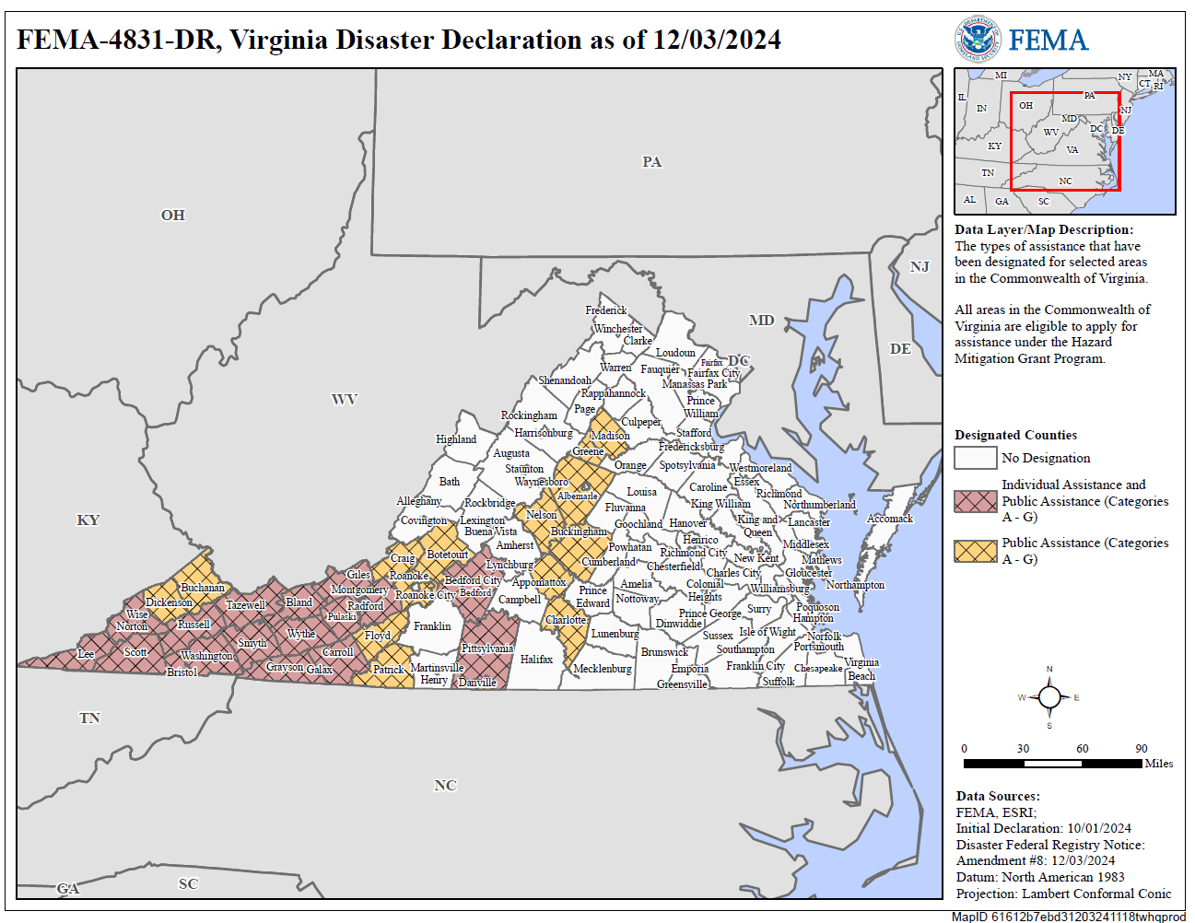

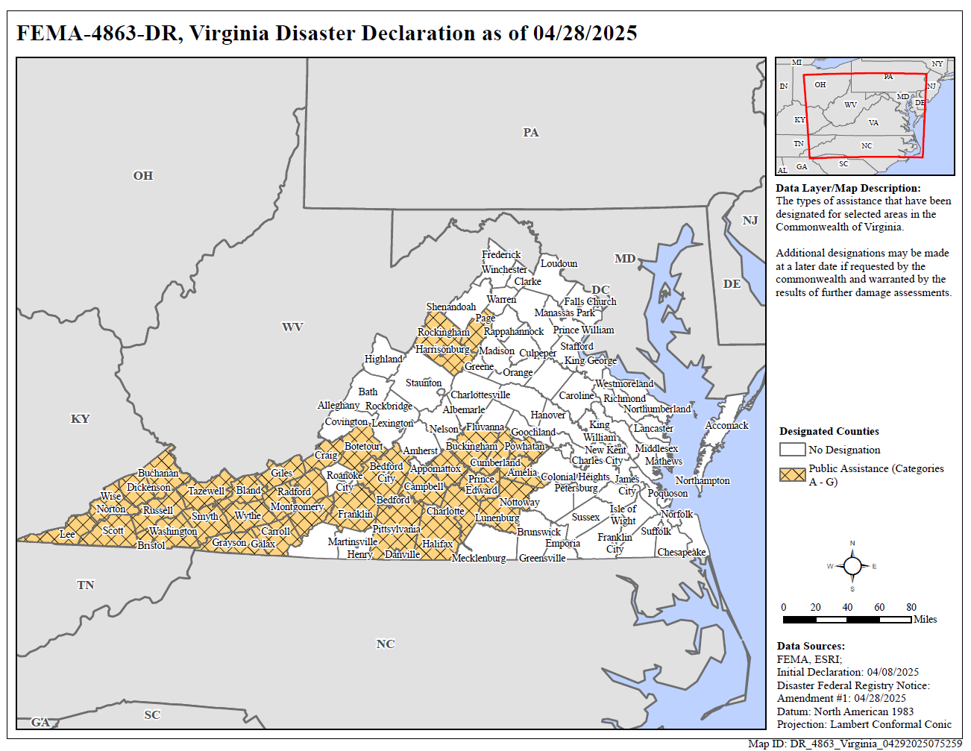

For the purposes of the Fund, §10.1-603.28 defines "Local government" as “any county, city, town, municipal corporation, authority, district, commission, or political subdivision created by the General Assembly or pursuant to the Constitution or laws of the Commonwealth or any combination of any two or more of the foregoing.”

