Virginia Flood Awareness Week 2021
Twitter Chat Planning Guide
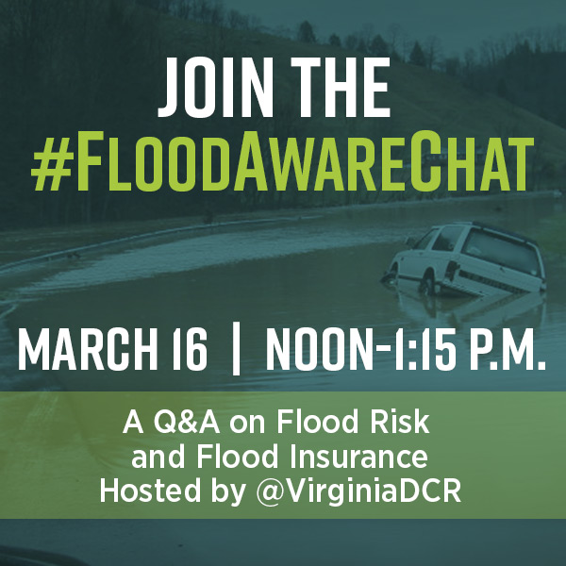

Background
Flooding is the most common and costly natural disaster, but only 3% of Virginians have flood insurance. It is estimated that 1 inch of water in a home can cause upwards of $25,000 in damages. Anywhere it can rain, it can flood. Most homeowners and renters insurance policies don’t cover flooding, so it’s important to act now. Virginia Flood Awareness Week, March 14-20, 2021, encourages people in Virginia and beyond to learn about their flood risk and protect the life they’ve built with flood insurance.

The Virginia Department of Conservation and Recreation (DCR) will host a Twitter Chat with community leaders, subject matter experts and individuals to offer information to the public to increase flood awareness so you can know your risk, protect your property and get flood insurance.

The Twitter Chat is an opportunity to:
- Give citizens the tools they need to identify their flood risk.
- Promote the purchase of flood insurance, so homeowners, renters, and businesses can recover faster and more completely.
- Encourage citizens to be flood aware: know the warnings, be prepared, and stay safe.

Twitter Chat Logistics
- Date: March 16, 2021
- Time: Noon – 1:00 P.M. Eastern Time
11:00AM Central | 10:00AM Mountain | 9:00AM Pacific
- Location: Online via Twitter
- Moderator: @VirginiaDCR
- Hashtag: #FloodAwareChat

Target Audiences

- Insurance agents
- Realtors
- Financial planners
- Public safety
- State & local floodplain managers
- State & local emergency managers
- Building & land use experts
- Water resource experts
- Individuals & families

First Time to a Twitter Chat?
It’s easy. To participate, all you need to do is tweet during the designated time using the conversation hashtag. @VirginiaDCR handle will moderate the conversation between participants. For a list of questions, timing and example answers, see page 4.

We encourage participants to answer from their perspective experience and use the example answers as guidance to begin your response. To answer a question, just begin your tweet with the answer to the numbered question (A1, A2, etc.). Feel free to customize your responses, add graphics and include your take!

Located in Virginia? Add the #FloodAwareVA hashtag to your answers, so Virginians can see your answers with the other Flood Awareness Week posts. This is the official hashtag for Virginia Flood Awareness Week.

Step-by-Step Instructions
To answer a question, watch for questions coming from Virginia DCR’s account. When you see the tweet with the question, click the retweet button on a Virginia DCR question and choose the “quote retweet” option.

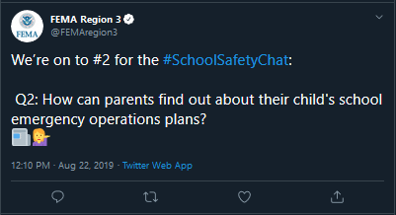
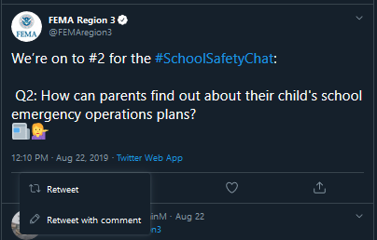
Below is an example from a previous Twitter chat by FEMA Region 3. In this example, at 12:10 PM, FEMA Region 3 posed the question “Q2: How can parents find out about their child’s school emergency operations plans?” The visuals below show you where you can find the retweet button and “retweet with comment” option to start your tweet.

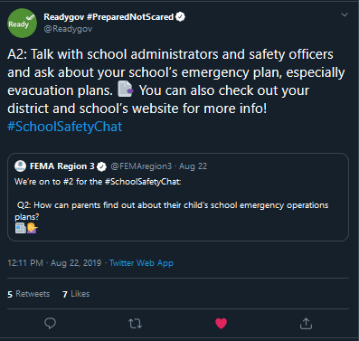
Begin your tweet with the Answer to the numbered question. For example, this was Q2. If you answer Q2, you would start your answer using “A2:”

Always include the hashtag #FloodAwareChat on your answers, so others can follow the conversation. Feel free to customize your responses with images, graphics, emojis or relevant gifs. During the chat, you can keep up with the #FloodAwareChat hashtag to see what other accounts are tweeting and avoid duplicating responses.

Sample Emojis
Simply copy and paste the emoji into your tweet if you choose to use one.
💧 Water | 🌊 Wave | 🌧 ⛈ Rain | 🌀 Hurricane
🌬 Wind | 🌨 ❄ Snow | ✅ Yes/Do | ❎ No/Don’t
🚒 🚑 🚓 Public Safety | 🚣 Boat/Rescue | 🚘 🚗 🚙 Car | 🗺️ Map
📅 Calendar | 📺 TV | 📻 Radio | ☎ 📱Phone
🏠 House | 🏚 Damaged House | 🏬 Business | 💵 Money
⚠ 📢 Alert | 🔦 Flashlight | 🛠 Tools | 🌳 Tree/Conservation
🏭 Factory | 🚱 Unsafe Water | 🍽 Food | 🐍 Snake/Wildlife

Messages to Promote #FloodAwareChat
- Flooding doesn’t only occur near a river or coastline - anywhere it can rain, it can flood. Join the #FloodAwareChat on 3/16 and learn about flood risk and flood insurance!
- Just 1 inch of water can cause more than $25,000 of damage to your home. Are you covered with flood insurance? Join the #FloodAwareChat on 3/16 to learn more!
- Learn more about how you can protect your home or business from floods by joining the #FloodAwareChat on 3/16!
- Floods are the nation’s most common and costly natural disaster. Learn more about flood risk and how you can protect yourself by joining our #FloodAwareChat on 3/16!
- Do you know the difference between a flood warning, flood watch and flood advisory? Join the #FloodAwareChat on 3/16 and learn how you can protect yourself and property from floods!

Questions and RSVPs
Please contact the Virginia DCR team if you have any questions. Feel free to share this with other relevant partners and stakeholders.

Virginia DCR Contacts
Name | Position | Email | Phone
Julie Buchanan | Sr. Public Relations & Marketing Specialist | Julie.buchanan@dcr.virginia.gov | 804-786-2292
Angela Davis | Floodplain Planner | Angela.davis@dcr.virginia.gov | 804-371-6135
Michael Barber | Floodplain Planner | Michael.barber@dcr.virginia.gov | 804-807-0476
Brandy Buford | Floodplain Planner | Brandy.buford@dcr.virginia.gov | 804-807-0461
Wendy Howard-Cooper | Division Director and NFIP Coordinator | Wendy.howard-cooper@dcr.virginia.gov | 804-786-5099

If you can RSVP in advance, we would really appreciate it! Please contact any of the DCR team before March 16 to let us know you are planning to participate.
Questions and Sample Answers

Noon EST
Welcome chat participants and ask them to introduce themselves in the comments section of the post.

12:05 p.m. EST
Q1: Floodwaters can be dangerous. Did you know 6 inches of water can knock a person off their feet? What other ways are floodwaters unsafe? #FloodAwareChat
- Example answers:
  - A1: Never drive through floodwaters. It only takes 6 inches of water to stall out most vehicles, and the road may be washed out under the water. #FloodAwareChat #TurnAroundDontDrown
  - A1: One foot of water can float a small car. Never drive through floodwaters. #FloodAwareChat #TurnAroundDontDrown
  - A1: Most vehicles will be carried away in only 2 feet of rushing water. Never drive through floodwaters. #FloodAwareChat #TurnAroundDontDrown
  - A1: Floodwaters can transport debris and other dangerous materials that you may not be able to see. Don’t walk through floodwaters. #FloodAwareChat
  - A1: Floodwaters can carry sewage, bacteria, and other pollutants that can make you sick. Avoid floodwaters, throw out any flooded food, and wash with soap and water if you do encounter floodwaters. #FloodAwareChat
  - A1: Downed power lines may be in floodwaters. Stay safe, avoid floodwaters. #FloodAwareChat
- Example answers for Virginia participants:
  - A1: Floods can displace wildlife, like snakes or alligators to areas they’re not usually seen. Be prepared and know who to call if you encounter wildlife after a flood. @VDGIF #FloodAwareChat #FloodAwareVA
  - A1: Wells can be flooded, contaminating drinking and/or processing water. If your well has been flooded, contact @VDHgov to confirm your water is contaminate free. #FloodAwareChat #FloodAwareVA
  - A1: Floods can result in large amounts of debris. Make sure your community has a debris management plan and is prepared. @VirginiaDEQ #FloodAwareChat #FloodAwareVA

The National Weather Service has flood safety graphics available that could be used in place of some of the example answers above: https://www.weather.gov/wrn/spring2017-flood-sm#sp4

12:15 p.m. EST
Q2: What kinds of flood risks are in your community? Who is at risk? #FloodAwareChat
- Example answers:
  - A2: My community experiences coastal and riverine flooding. Everyone is at risk, because anywhere it can rain, it can flood. #FloodAwareChat
  - A2: My community experiences flash flooding. People living near the river and in low-lying areas are at the greatest risk. #FloodAwareChat
  - A2: My community has a dam designed to protect against flooding. Dams can be overtopped or fail when put under extreme pressure by large amounts of water. People living downstream are at risk. #FloodAwareChat
- Example answers for Virginia participants:
  - A2: Shockoe Bottom in Richmond is protected by the floodwall but can still experience flooding from rain events. Residents and business owners should be protected with flood insurance. #FloodAwareChat #FloodAwareVA
  - A2: [STREET NAME] may flood during light rain or high tide. Residents & visitors should be aware that vehicles could be at risk, and traffic patterns may change during flooding. #FloodAwareChat #FloodAwareVA

12:20 p.m. EST
Q3: Did you know there are different emergency alerts for floods? What systems/tools provide emergency alert notifications in your community? #FloodAwareChat
- Example answers:
  - A3: @NWS issues alerts for flooding. Warnings mean to take action. Watches mean to be prepared. Advisories mean to be aware. #FloodAwareChat https://www.weather.gov/safety/flood-watch-warning
  - A3: Flash floods can happen suddenly. A watch means flooding is possible, so you should be prepared. A warning means flooding is happening and you need to get to higher ground immediately. #FloodAwareChat
  - A3: A flood watch means flooding is possible. Stay alert and get prepared in case flooding does occur. #FloodAwareChat
  - A3: A flood warning means flooding is happening or about to. #FloodAwareChat
  - A3: Evacuation alerts may be issued due to flooding. Always evacuate immediately. #FloodAwareChat
  - A3: Get real-time text or email alerts when nearby stream gages hit certain levels using @USGS WaterAlert. #FloodAwareChat https://maps.waterdata.usgs.gov/mapper/wateralert/
  - A3: Local TV and radio stations provide weather alerts. #FloodAwareChat
  - A3: @NWS sends text messages for severe weather alerts. #FloodAwareChat
- Example answers for Virginia participants:
  - A3: [COMMUNITY NAME] has a text alert system to warn citizens of flood events. Sign up today! #FloodAwareChat #FloodAwareVA [INSERT LINK]
  - A3: Be prepared before you go. Follow @VaDOT or visit 511 Virginia for traffic alerts and road closures. #FloodAwareChat @FloodAwareVA https://www.511virginia.org/

The National Weather Service has graphics available that explain the different flood alerts that could be used in place of some of the example answers above: https://www.weather.gov/wrn/spring2017-flood-sm#sp4

12:30 p.m. EST
Q4: Why is flood insurance important and who is eligible to purchase a policy? #FloodAwareChat
- Example answers:
  - A4: Most homeowners and renters insurance policies do not cover flood damages. #FloodAwareChat
  - A4: Flood insurance offers peace of mind that you can recover after a flood. Protect the life you’ve built. #FloodAwareChat
  - A4: Federal disaster assistance is not available for all flood events and is not designed to restore your home or replace your belongings. Flood insurance can, even without a disaster declaration. #FloodAwareChat
  - A4: After Hurricane Harvey, the average disaster assistance payment was $4,000 vs. the average flood insurance payment of $110,000. Protect your property. Get flood insurance. #FloodAwareChat
  - A4: Anyone living in an NFIP participating community is eligible for flood insurance, even if you live outside of a mapped floodplain. #FloodAwareChat
  - A4: Private flood insurance policies may be available to residents living in non-NFIP participating communities. #FloodAwareChat
  - A4: Homeowners, renters, and business owners can purchase flood insurance. #FloodAwareChat
- Example answer for Virginia participants:
  - A4: After Hurricane Matthew, the average flood insurance payment was $35,000 vs. the average disaster assistance payment of $4,000. #FloodAwareChat #FloodAwareVA
  - A4: During Hurricane Matthew, 70% of damaged structures were outside of high-risk flood zones. Anywhere it can rain, it can flood. #FloodAwareChat #FloodAwareVA
  - A4: [COMMUNITY NAME] participates in the National Flood Insurance Program, so that ALL of our residents are eligible for flood insurance. #FloodAwareChat #FloodAwareVA

12:35 p.m. EST
Q5: What tools and resources are available to learn about flood insurance and assist in identifying a property’s flood risk? #FloodAwareChat
- Example answers:
  - A5: The Virginia Flood Risk Information System can be used to find out if a property is located in a FEMA flood zone. #FloodAwareChat #FloodAwareVA https://www.dcr.virginia.gov/dam-safety-and-floodplains/fpvfris.php
  - A5: Flood Insurance Rate Map information, letters of map change, and GIS data can be downloaded from FEMA’s Map Service Center. #FloodAwareChat http://msc.fema.gov/
  - A5: Visit [COMMUNITY NAME]’s local GIS map to find out if your property is in a flood zone. #FloodAwareChat
  - A5: Visit FloodSmart.gov to learn more about flood insurance. #FloodAwareChat https://www.floodsmart.gov/
  - A5: FEMA has resources available for insurance agents to learn more about flood insurance. #FloodAwareChat https://agents.floodsmart.gov/
- Example answers for Virginia participants:
  - A5: The Virginia Dam Safety Inventory System lets users access info on all dams in VA. #FloodAwareChat #FloodAwareVA https://www.dcr.virginia.gov/dam-safety-and-floodplains/ds-dsis
  - A5: Live in coastal VA? Know if you live in a hurricane evacuation zone and how to be prepared. Hurricane season starts June 1! #FloodAwareChat #KnowYourZone #FloodAwareVA https://www.vaemergency.gov/hurricane-evacuation-zone-lookup/
  - A5: In coastal VA? Use @VIMS_News Tidewatch to help prepare for coastal flooding. #FloodAwareChat #FloodAwareVA
  - A5: The City of Franklin has flood inundation mapping so you can learn when flooding will start to happen and where. #FloodAwareChat #FloodAwareVA https://water.weather.gov/ahps2/inundation/index.php?gage=fklv2
  - A5: [INSURANCE COMPANY NAME] sells flood insurance policies in [COMMUNITY NAME]. Talk to an agent today, and make sure you’re covered. #FloodAwareChat #FloodAwareVA
A list of FEMA publications related to flood insurance is available on DCR’s website. You may want to link to one of these documents as part of your answer, or they may give you ideas for different answers. https://www.dcr.virginia.gov/dam-safety-and-floodplains/floodawareness-publications

FEMA has social media graphics available that you may want to use to support for answers related to the flood insurance questions above. https://agents.floodsmart.gov/Resource-Library

12:45 p.m. EST
Q6: Aside from purchasing flood insurance, what are other ways to mitigate flood risk & #BePrepared? Now’s a great time for our partnering @boyscouts to share their work on the Silver Jackets Flood Risk Activity Book! #FloodAwareChat
- Example answers:
  - A6: Creating an emergency preparedness kit and action plan or checklist to refer to in the event of a flooding emergency. #FloodAwareChat
  - A6: Sign up for emergency alert systems in your community to be informed of any inclement weather or flooding emergencies. #FloodAwareChat
  - A6: Installing a rain barrel may reduce runoff and localized flooding on your property. #FloodAwareChat
  - A6: Regularly clean out your gutters and downspouts to make sure rainwater drains away from your home properly. #FloodAwareChat
  - A6: Do you have a crawlspace? Install flood vents to allow floodwaters to automatically flow in/out to protect your foundation. It’s important to make sure the flood vents are clear of debris, not blocked off, and functioning properly. #FloodAwareChat
  - A6: Check out @FEMAregion3 low cost projects you can do to protect your home from flooding. #FloodAwareChat https://www.fema.gov/media-library-data/1528734155205-5dba7257256260a5785db8bf7a63243e/Protect_Your_Home_From_Flooding_Brochure.pdf
- Example answers for Virginia participants:
  - A6: Elevating your home can reduce your flood risk. [COMMUNITY NAME] may be able to help cover this cost with mitigation grants. #FloodAwareChat #FloodAwareVA [INSERT LINK OR CONTACT INFO]
  - A6: Hazard mitigation grants may be available to mitigate flood risk to your home or community. Learn more @VDEM #FloodAwareChat #FloodAwareVA https://www.vaemergency.gov/grants/hazard-mitigation-assistance-grant-programs/

12:55 p.m. EST
Q7: This week is also Severe Weather Awareness Week. What types of severe weather can cause flooding? #FloodAwareChat
- Example answers:
  - A7: Thunderstorms produce high rates of rainfall and can cause flooding in urban and rural areas. #FloodAwareChat
  - A7: Thunderstorms that rain or move over the same location repeatedly in a short period of time, less than 6 hours, are especially dangerous and can produce extreme flooding. #FloodAwareChat
  - A7: Any type of tropical system typically brings excessive moisture & potential for significant flooding. Virginia has a history of flooding from tropical systems like Hurricanes Floyd & Isabel and remnant systems like Hurricanes Agnes & Camille. #FloodAwareChat
1:00 p.m. EST
Q8: In an urban setting, how long does it take before a thunderstorm producing heavy rain begins to cause flash flooding? #FloodAwareChat
- Example answer:
  - Usually 30 min. or less. Rainfall rates in thunderstorms are generally 2 to 4 inches per hour. One inch of rain falling in a short period will typically result in flash flooding. Roads can quickly turn into flowing rivers with swift moving water. #FloodAwareChat
1:05 p.m. EST
Q9: What is the No. 1 cause of death during a flood? #FloodAwareChat
- Example answer:
  - Driving into the water. Most deaths occur in vehicles. Just 1-2 feet of water will push and carry away most vehicles. Turn Around Don&#39;t Down anytime you approach a flooded roadway. In many cases it is impossible to accurately judge the depth of the water. #FloodAwareChat

1:10 p.m. EST
Q10: Do you have anything else you’d like to share about flood risk, flood awareness or flood insurance? #FloodAwareChat
- Example answers:
  - A8: Preferred Risk Policies for properties outside of high-risk flood zones can be purchased for as little as $325 a year! #FloodAwareChat
  - A8: Flood insurance policies take 30 days to go into effect. Don’t wait until the flood comes. Be prepared, so you can protect the life you’ve built. #FloodAwareChat
  - A8: Learn more about what to do before, during, and after a flood. #FloodAwareChat https://www.ready.gov/floods
  - A8: The @RedCross has information available to help you prepare for a flood. #FloodAwareChat https://www.redcross.org/get-help/how-to-prepare-for-emergencies/types-of-emergencies/flood.html
- Example answers for Virginia participants:
  - A8: [COMMUNITY NAME] participates in the Community Rating System, so residents can get a [CRS % Discount] discount on NFIP flood insurance policies. #FloodAwareChat #FloodAwareVA
  - A8: Use the @VDEM Flood Safety guide to help you prepare for a flood. #FloodAwareChat #FloodAwareVA https://www.vaemergency.gov/threats/floods/
  - A8: Hurricanes affect coastal AND inland communities in VA. Use the @VDEM Hurricane Preparedness guide to learn more about hurricanes about how to be prepared. #FloodAwareChat #FloodAwareVA https://www.vaemergency.gov/threats/hurricanes/

1:15 p.m. EST
Close the Twitter chat and thank participants.

