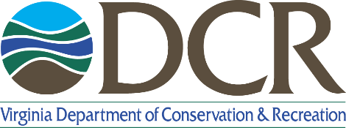
Land and Water Conservation Fund
Virginia 2024 Project Timeline
Please read the Virginia LWCF 2024 Application Manual before inserting the project timeline.
2024 Project Timeline
Insert a timeline for completion of the proposed LWCF project on the following pages.
Important dates to remember:
- It is estimated that project sponsors will be notified of DCR selection in early May 2024.
- For projects submitted to NPS this grant round, NPS authorization date of October 2024 to January 2025 is expected but cannot be guaranteed.
- Projects will be authorized for 3 years from NPS authorization date.
- Development projects must break ground within one year of NPS authorization date but cannot begin construction until award authorization and notice of award.

Sample tasks/milestones to include:
Indicate which steps have been completed within the timeline as well as noting a timeline for actions that need to be completed.

All Projects (as applicable)
- Environmental Review Compliance data collection (NEPA).
- Historic/Cultural Resources Compliance data collection (Section 106).
  - See https://www.dcr.virginia.gov/recreational-planning/lwcf for review guidance.
  - NEPA and Section 106 must be completed as soon as possible, otherwise NPS may not accept applications and deem them non-eligible for Federal funding.
- Indicate when committed funds will be secured.
- Time to complete/resolve any easement/lease/ownership etc. issues.
- Projected date open to public

Acquisition
- Proposal and planning process
- Appraisals (UASFLA Standards) and appraisal review
- Negotiations/Purchase offer with landowners if necessary

Development - Include all that apply
- Survey work
- Preliminary design development
- Final plan development
- Construction drawing preparation
- City/County/Other - Reviews/Approvals
- Bidding process
- Permitting
- Construction period
- Date open to public

